FOR IMMEDIATE RELEASE

August 13, 2021

**BENDIGO FLETCHER RELEASE DEBUT ALBUM *FITS OF LAUGHTER***

**LISTEN**[**HERE**](https://nam04.safelinks.protection.outlook.com/?url=https%3A%2F%2Fbendigofletcher.lnk.to%2Ffitsoflaughter&data=04%7C01%7CSydneyWorden%40elektra.com%7C496651e9ae1c4829030008d95e5ab6bc%7C8367939002ec4ba1ad3d69da3fdd637e%7C0%7C0%7C637644565979240270%7CUnknown%7CTWFpbGZsb3d8eyJWIjoiMC4wLjAwMDAiLCJQIjoiV2luMzIiLCJBTiI6Ik1haWwiLCJXVCI6Mn0%3D%7C1000&sdata=zSIQXzkn%2FieQXHhqs0ghNSyEZJJR%2BjQxh%2BTZXrTbOGs%3D&reserved=0)

**BAND UNVEILS OFFICIAL MUSIC VIDEO FOR “EVERGREEN”**

**WATCH**[**HERE**](https://nam04.safelinks.protection.outlook.com/?url=https%3A%2F%2Fyoutu.be%2FanSo2V8XADE&data=04%7C01%7CSydneyWorden%40elektra.com%7C496651e9ae1c4829030008d95e5ab6bc%7C8367939002ec4ba1ad3d69da3fdd637e%7C0%7C0%7C637644565979430161%7CUnknown%7CTWFpbGZsb3d8eyJWIjoiMC4wLjAwMDAiLCJQIjoiV2luMzIiLCJBTiI6Ik1haWwiLCJXVCI6Mn0%3D%7C1000&sdata=%2FHE7hFAdp1ng0yt%2F9g4%2FPscE8wuH%2F%2FQUUNCgTq5wKx0%3D&reserved=0)

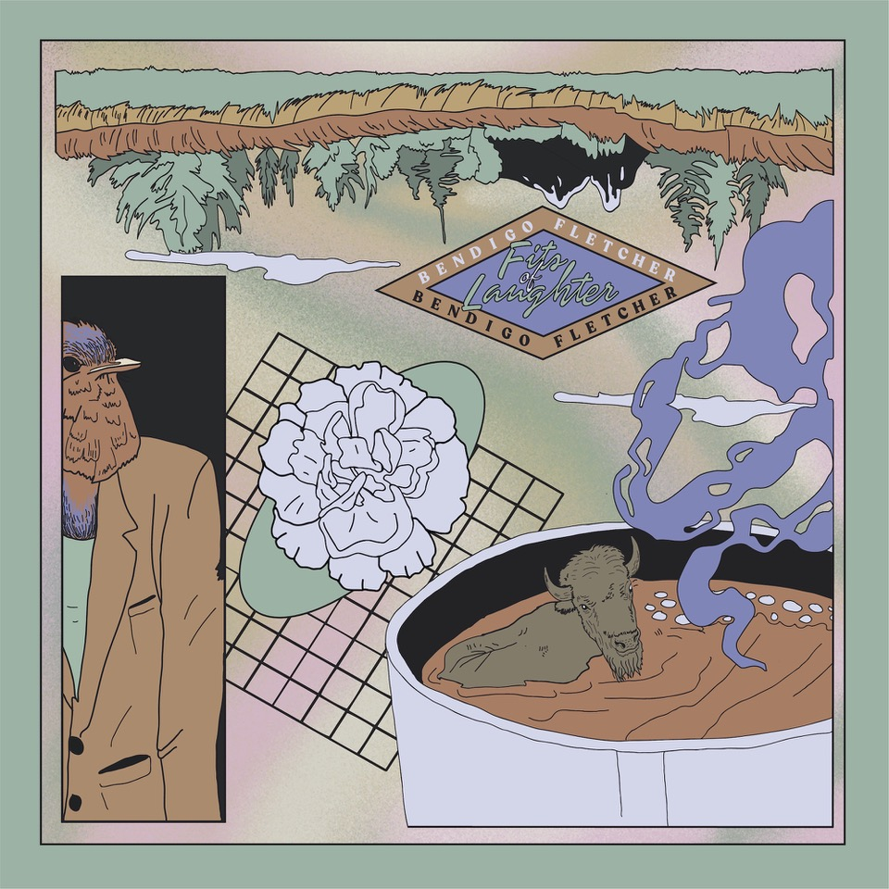

*“Somewhere between the post-Woodstock folk scene of the ‘70s and that decade’s burgeoning hard rock movement”****FLOOD Magazine***

*“Alt-rock, country-flecked folk-rock soaked in LSD”****Music Connection***

*“Denser psych-rock with some remaining elements of Bendigo Fletcher’s drifting folk-Americana roots”* ***American Songwriter***

Louisville, KY’s **Bendigo Fletcher** have released their anxiously awaited debut album ***Fits of Laughter****.*The album is available physically and digitally starting todayvia Elektra Records [HERE](https://nam04.safelinks.protection.outlook.com/?url=https%3A%2F%2Fbendigofletcher.lnk.to%2Ffitsoflaughter&data=04%7C01%7CSydneyWorden%40elektra.com%7C496651e9ae1c4829030008d95e5ab6bc%7C8367939002ec4ba1ad3d69da3fdd637e%7C0%7C0%7C637644565979440156%7CUnknown%7CTWFpbGZsb3d8eyJWIjoiMC4wLjAwMDAiLCJQIjoiV2luMzIiLCJBTiI6Ik1haWwiLCJXVCI6Mn0%3D%7C1000&sdata=wucMXb444YCvzV2C5%2FmqFdNwHxkgbLBc0fgADK4Dw6k%3D&reserved=0). Merch bundles and limited edition colored vinyl are available exclusively through the band’s online store [HERE](https://nam04.safelinks.protection.outlook.com/?url=https%3A%2F%2Fstore.warnermusic.com%2Felektra-records%2Fartists%2Fbendigo-fletcher.html&data=04%7C01%7CSydneyWorden%40elektra.com%7C496651e9ae1c4829030008d95e5ab6bc%7C8367939002ec4ba1ad3d69da3fdd637e%7C0%7C0%7C637644565979440156%7CUnknown%7CTWFpbGZsb3d8eyJWIjoiMC4wLjAwMDAiLCJQIjoiV2luMzIiLCJBTiI6Ik1haWwiLCJXVCI6Mn0%3D%7C1000&sdata=pt1YfKqEddhdk0IoxaD7lXiD4T5nLUtY%2FOKiTrTg%2FVU%3D&reserved=0). The band has also unveiled a brand new official music video for lead single “Evergreen”, which was co-directed by Bendigo Fletcher frontman Ryan Anderson and Nate Spicer. Watch it on their YouTube channel [HERE](https://nam04.safelinks.protection.outlook.com/?url=https%3A%2F%2Fyoutu.be%2FanSo2V8XADE&data=04%7C01%7CSydneyWorden%40elektra.com%7C496651e9ae1c4829030008d95e5ab6bc%7C8367939002ec4ba1ad3d69da3fdd637e%7C0%7C0%7C637644565979450145%7CUnknown%7CTWFpbGZsb3d8eyJWIjoiMC4wLjAwMDAiLCJQIjoiV2luMzIiLCJBTiI6Ik1haWwiLCJXVCI6Mn0%3D%7C1000&sdata=OGw7SIJ0ozPn4pqk7UDRAVJqGrDAgPQZhQm29fE6nRY%3D&reserved=0).

In sharing *Fits of Laughter* with the world, Bendigo Fletcher hopes to guide listeners toward a deeper trust in their own intuition and instinct. “There’s always going to be other people’s opinions and judgments and ideas on how to live, and more often than not, those ideas come from a place of love” shares Anderson. “But ultimately every person knows what truth feels like, as opposed to artifice or putting up walls to get through something you feel you’re expected to do. I suppose these songs are sort of my offering to others, to encourage them to look for that feeling in their own lives, and then follow through on it.”

Throughout *Fits of Laughter,*Anderson crafts the patchwork poetry of his lyrics by serenely observing the world around him. When matched with the band’s gorgeous collision of country and folk-rock and dreamy psychedelia, the result is story-songs graced with raw humanity, wildly offbeat humor, and a transcendent sense of wonder. For help in forging the album’s ragged elegance, Bendigo Fletcher worked with producer Ken Coomer, laying down the album in nine frenetic days. The albumbears an undeniable immediacy, thanks in part to the band’s decision to limit the tracklist to eight essential songs (a move largely inspired by extraordinarily lean and iconic albums like Television’s *Marquee Moon*).

Bendigo Fletcher announced their Elektra Records signing in an exclusive interview with *American Songwriter*, and previewed *Fits of Laughter* with the release of lead single “[Evergreen](https://nam04.safelinks.protection.outlook.com/?url=https%3A%2F%2Fbendigo.lnk.to%2Fevergreen&data=04%7C01%7CSydneyWorden%40elektra.com%7C496651e9ae1c4829030008d95e5ab6bc%7C8367939002ec4ba1ad3d69da3fdd637e%7C0%7C0%7C637644565979450145%7CUnknown%7CTWFpbGZsb3d8eyJWIjoiMC4wLjAwMDAiLCJQIjoiV2luMzIiLCJBTiI6Ik1haWwiLCJXVCI6Mn0%3D%7C1000&sdata=Y9BdDWOn0sZ7mi92PjNGmDi6wZXjyW5yI7HwebnV%2FEI%3D&reserved=0)” earlier this year. This summer, the band returned with the album’s groove-heavy opener “[Sugar in the Creek](https://nam04.safelinks.protection.outlook.com/?url=https%3A%2F%2Fbendigofletcher.lnk.to%2Fsugarinthecreek&data=04%7C01%7CSydneyWorden%40elektra.com%7C496651e9ae1c4829030008d95e5ab6bc%7C8367939002ec4ba1ad3d69da3fdd637e%7C0%7C0%7C637644565979460143%7CUnknown%7CTWFpbGZsb3d8eyJWIjoiMC4wLjAwMDAiLCJQIjoiV2luMzIiLCJBTiI6Ik1haWwiLCJXVCI6Mn0%3D%7C1000&sdata=PiQtH628qi7RrMeLhLKIfxo9uxDHUyud2QKAn%2Fh6%2FQk%3D&reserved=0)” and an accompanying animated [music video](https://nam04.safelinks.protection.outlook.com/?url=https%3A%2F%2Fyoutu.be%2FkP9RJnmniDU&data=04%7C01%7CSydneyWorden%40elektra.com%7C496651e9ae1c4829030008d95e5ab6bc%7C8367939002ec4ba1ad3d69da3fdd637e%7C0%7C0%7C637644565979460143%7CUnknown%7CTWFpbGZsb3d8eyJWIjoiMC4wLjAwMDAiLCJQIjoiV2luMzIiLCJBTiI6Ik1haWwiLCJXVCI6Mn0%3D%7C1000&sdata=yO8Ln%2F6oLqzeM%2BSyacCKtdZqck%2FchJoaaXOAR33ntaU%3D&reserved=0), and unveiled the track [“Astro Pup”](https://nam04.safelinks.protection.outlook.com/?url=https%3A%2F%2Fwww.youtube.com%2Fwatch%3Fv%3Dmm85lPeevM8&data=04%7C01%7CSydneyWorden%40elektra.com%7C496651e9ae1c4829030008d95e5ab6bc%7C8367939002ec4ba1ad3d69da3fdd637e%7C0%7C0%7C637644565979470138%7CUnknown%7CTWFpbGZsb3d8eyJWIjoiMC4wLjAwMDAiLCJQIjoiV2luMzIiLCJBTiI6Ik1haWwiLCJXVCI6Mn0%3D%7C1000&sdata=9I4MwboWyJf%2FLLL9OS4VmQYGvrT1mQFdElkbRbPPSq0%3D&reserved=0). The band also shared a series of live performances from Louisville, KY’s Blackacre Farm on their official [YouTube channel](https://nam04.safelinks.protection.outlook.com/?url=https%3A%2F%2Fwww.youtube.com%2Fchannel%2FUCqWvWwv7K8kq3PZnygVG1BA%2Fvideos&data=04%7C01%7CSydneyWorden%40elektra.com%7C496651e9ae1c4829030008d95e5ab6bc%7C8367939002ec4ba1ad3d69da3fdd637e%7C0%7C0%7C637644565979470138%7CUnknown%7CTWFpbGZsb3d8eyJWIjoiMC4wLjAwMDAiLCJQIjoiV2luMzIiLCJBTiI6Ik1haWwiLCJXVCI6Mn0%3D%7C1000&sdata=p6158Gr622EvtiAZSJ%2BWPnSx0C8FEd82of8NGfK5WBc%3D&reserved=0). *Fits of Laughter’s*early releases received praise from *FLOOD Magazine, The Bluegrass Situation, Music Connection,*and more. 

Later this month, Bendigo Fletcher will return to the road for a run of headline shows and festival appearances. In the Fall and Winter, the band will support labelmate Anderson East on both legs of his Maybe We Never Die Tour of North America. The 22-city trek kicks off on October 21, 2021 with two nights at Los Angeles, CA’s famed Troubadour, and wraps on February 02, 2022 at Toronto, Canada’s Danforth Music Hall. A complete list of live dates and ticket information can be found [HERE](https://nam04.safelinks.protection.outlook.com/?url=https%3A%2F%2Fwww.bendigofletcher.com%2F&data=04%7C01%7CSydneyWorden%40elektra.com%7C496651e9ae1c4829030008d95e5ab6bc%7C8367939002ec4ba1ad3d69da3fdd637e%7C0%7C0%7C637644565979480132%7CUnknown%7CTWFpbGZsb3d8eyJWIjoiMC4wLjAwMDAiLCJQIjoiV2luMzIiLCJBTiI6Ik1haWwiLCJXVCI6Mn0%3D%7C1000&sdata=4GOGDaFKI%2BJZwxuSLRsUxs%2Bxk%2B1YD1RlDIC8AKKIKHQ%3D&reserved=0).

*Fits of Laughter* follows a trio of independent EPs that quietly amassed millions of streams and earned praise from *Pop Matters*, *Atwood Magazine*, and more. Converting audiences to fans on the road, Bendigo Fletcher has supported Mt. Joy, Nathaniel Rateliff, Rayland Baxter, Caamp, and Hiss Golden Messenger on tour. Bendigo Fletcher is: Ryan Anderson (lead vocals, guitar, banjo) - Andrew Shupert (backing vocals, lead guitar) - Evan Wagner (backing vocals, keys, guitar, auxiliary percussion) - Conner Powell (bass) - Chris Weis (drums).

***Fits of Laughter* Tracklisting**

1. Sugar in the Creek

2. Birding

3. Donkey Boy Blues

4. Buffalo Rodeo

5. Evergreen

6. Astro Pup

7. Retail Lord

8. Ulterior Motives

**Bendigo Fletcher Tour Dates**

**Headline Shows and Festival Appearances**

August 25, 2021 - Indianapolis, IN - Hi-Fi#

August 26, 2021 - St. Louis, MO - Blueberry Hill*

August 27, 2021 - Chicago, IL - Schubas#

August 28, 2021 - Lexington, KY - Railbird Music Festival^

November 11, 2021 - Oxford, MS - Proud Larry’s*

November 12, 2021 - Jackson, MS - Duling Hall*

November 13, 2021 - New Orleans, LA - Gasa Gasa*

November 14, 2021 - Birmingham, AL - Saturn*

November 16, 2021 - Asheville, NC - Asheville Music Hall*

November 17, 2021 - Chattanooga, TN - Songbirds*

November 18, 2021 - Knoxville, TN - Barley’s Taproom*

November 19, 2021 - Cincinnati, OH - The Woodward+

^festival appearance

#headline show

*co-headline with ONA

+co-headline with Sylmar

**Supporting Anderson East**

October 21, 2021 - Los Angeles, CA - Troubadour

October 22, 2021 - Los Angeles, CA - Troubadour

October 23, 2021 - San Diego, CA - Observatory North Park

October 24, 2021 - San Francisco, CA - The Fillmore

October 26, 2021 - Crystal Bay, NV - Crystal Bay Casino

October 28, 2021 - Portland, OR - Roseland Theater

October 29, 2021 - Eugene, OR - WOW Hall

October 30, 2021 - Seattle, WA - The Showbox

October 31, 2021 - Vancouver, Canada - Rickshaw Theatre

November 02, 2021 - Boise, ID - Knitting Factory Concert House

November 03, 2021 - Salt Lake City, UT - The Commonwealth Room

November 05, 2021 - Englewood, CO - Gothic Theatre

January 13, 2022 - Atlanta, GA - Variety Playhouse

January 14, 2022 - Charlotte, NC - The Fillmore Charlotte

January 15, 2022 - Raleigh, NC - Lincoln Theatre

January 18, 2022 - Washington, DC - 9:30 Club

January 21, 2022 - New York, NY - Webster Hall

January 22, 2022 - Philadelphia, PA - Union Transfer

January 23, 2022 - Charlottesville, VA - Jefferson Theater

January 25, 2022 - South Burlington, VT - Higher Ground

January 26, 2022 - Portland, ME - State Theatre

January 28, 2022 - Boston, MA - Paradise Rock Club

February 01, 2022 - Millvale, PA - Mr Small’s Theatre

February 02, 2022 - Toronto, Canada - The Danforth Music Hall

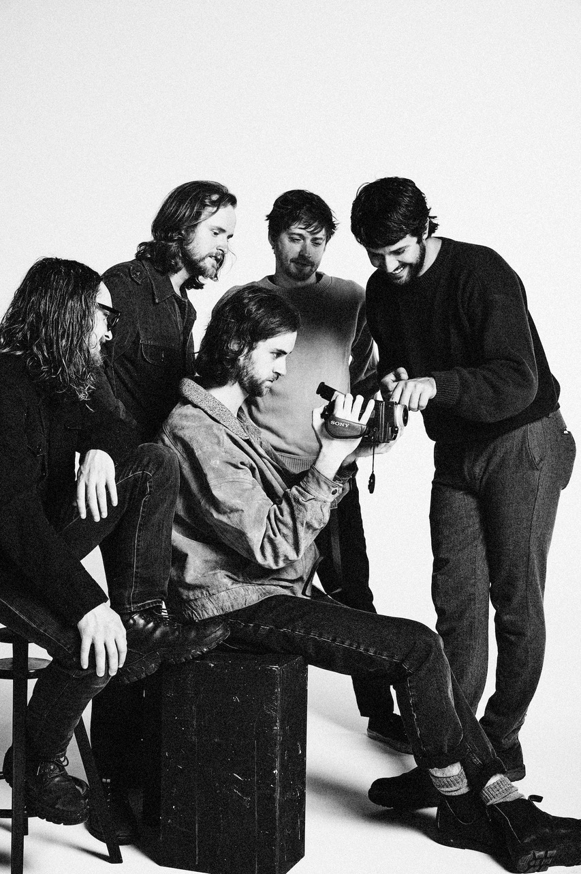

*Photo credit: Jimmy Fontaine*

[BendigoFletcher.com](https://nam04.safelinks.protection.outlook.com/?url=http%3A%2F%2Fbendigofletcher.com%2F&data=04%7C01%7CSydneyWorden%40elektra.com%7C496651e9ae1c4829030008d95e5ab6bc%7C8367939002ec4ba1ad3d69da3fdd637e%7C0%7C0%7C637644565979480132%7CUnknown%7CTWFpbGZsb3d8eyJWIjoiMC4wLjAwMDAiLCJQIjoiV2luMzIiLCJBTiI6Ik1haWwiLCJXVCI6Mn0%3D%7C1000&sdata=DwnjXSoisNE7dEIwJsn0Ol9pXmx3ckFc4n%2BMPRTyboc%3D&reserved=0)

[Facebook](https://nam04.safelinks.protection.outlook.com/?url=https%3A%2F%2Fwww.facebook.com%2Fbendigofletcher%2F&data=04%7C01%7CSydneyWorden%40elektra.com%7C496651e9ae1c4829030008d95e5ab6bc%7C8367939002ec4ba1ad3d69da3fdd637e%7C0%7C0%7C637644565979490127%7CUnknown%7CTWFpbGZsb3d8eyJWIjoiMC4wLjAwMDAiLCJQIjoiV2luMzIiLCJBTiI6Ik1haWwiLCJXVCI6Mn0%3D%7C1000&sdata=NXO3zPwFKZPGOypH4vElUmn%2BvEY4oQvxFgbugfmiZYo%3D&reserved=0) | [Instagram](https://nam04.safelinks.protection.outlook.com/?url=https%3A%2F%2Fwww.instagram.com%2Fbendigofletcher%2F%3Fhl%3Den&data=04%7C01%7CSydneyWorden%40elektra.com%7C496651e9ae1c4829030008d95e5ab6bc%7C8367939002ec4ba1ad3d69da3fdd637e%7C0%7C0%7C637644565979490127%7CUnknown%7CTWFpbGZsb3d8eyJWIjoiMC4wLjAwMDAiLCJQIjoiV2luMzIiLCJBTiI6Ik1haWwiLCJXVCI6Mn0%3D%7C1000&sdata=ZPbgTr7oOdLZKpc9nJeWq8%2FlxhP7q8X%2FdCkY%2BY35bvQ%3D&reserved=0) | [Twitter](https://nam04.safelinks.protection.outlook.com/?url=https%3A%2F%2Ftwitter.com%2Fbendigofletcher%3Flang%3Den&data=04%7C01%7CSydneyWorden%40elektra.com%7C496651e9ae1c4829030008d95e5ab6bc%7C8367939002ec4ba1ad3d69da3fdd637e%7C0%7C0%7C637644565979490127%7CUnknown%7CTWFpbGZsb3d8eyJWIjoiMC4wLjAwMDAiLCJQIjoiV2luMzIiLCJBTiI6Ik1haWwiLCJXVCI6Mn0%3D%7C1000&sdata=kJRRkKaOhgjDEezX5MFmnHCsNVdAnsYapraqslfWeZI%3D&reserved=0) | [YouTube](https://nam04.safelinks.protection.outlook.com/?url=https%3A%2F%2Fwww.youtube.com%2Fchannel%2FUCqWvWwv7K8kq3PZnygVG1BA&data=04%7C01%7CSydneyWorden%40elektra.com%7C496651e9ae1c4829030008d95e5ab6bc%7C8367939002ec4ba1ad3d69da3fdd637e%7C0%7C0%7C637644565979500120%7CUnknown%7CTWFpbGZsb3d8eyJWIjoiMC4wLjAwMDAiLCJQIjoiV2luMzIiLCJBTiI6Ik1haWwiLCJXVCI6Mn0%3D%7C1000&sdata=je%2BQcsx%2FcO5DWK8iMgiiY1CecLP7inplAOftW9IWaqo%3D&reserved=0)

**Press contact:**

Collin Citron | [CollinCitron@elektra.com](mailto:CollinCitron@elektra.com)