FOR IMMEDIATE RELEASE

July 28, 2021

**BENDIGO FLETCHER ANNOUNCE ADDITIONAL US TOUR DATES**

**DEBUT ALBUM *FITS OF LAUGHTER*OUT AUGUST 13 ON ELEKTRA RECORDS**

**PRE-ORDER**[**HERE**](https://nam04.safelinks.protection.outlook.com/?url=http%3A%2F%2Fbendigofletcher.lnk.to%2Ffitsoflaughter&data=04%7C01%7CSydneyWorden%40elektra.com%7C43b5d0facf8948b3903508d951e3736e%7C8367939002ec4ba1ad3d69da3fdd637e%7C0%7C0%7C637630859609593694%7CUnknown%7CTWFpbGZsb3d8eyJWIjoiMC4wLjAwMDAiLCJQIjoiV2luMzIiLCJBTiI6Ik1haWwiLCJXVCI6Mn0%3D%7C1000&sdata=CskkmyGzONRQ4mLUgUZmRsZ8JNXbrMqk3CNj2Rw84nI%3D&reserved=0)

**WATCH THE BAND PERFORM “ASTRO PUP” LIVE FROM LOUISVILLE, KY’S BLACKACRE FARM**[**HERE**](https://nam04.safelinks.protection.outlook.com/?url=https%3A%2F%2Fyoutu.be%2F1oOJckAP13w&data=04%7C01%7CSydneyWorden%40elektra.com%7C43b5d0facf8948b3903508d951e3736e%7C8367939002ec4ba1ad3d69da3fdd637e%7C0%7C0%7C637630859609603688%7CUnknown%7CTWFpbGZsb3d8eyJWIjoiMC4wLjAwMDAiLCJQIjoiV2luMzIiLCJBTiI6Ik1haWwiLCJXVCI6Mn0%3D%7C1000&sdata=Zsd7JmOMhJ968YgPpgaoDkZZHDdP3KBgY3It2qH%2BL7Y%3D&reserved=0)

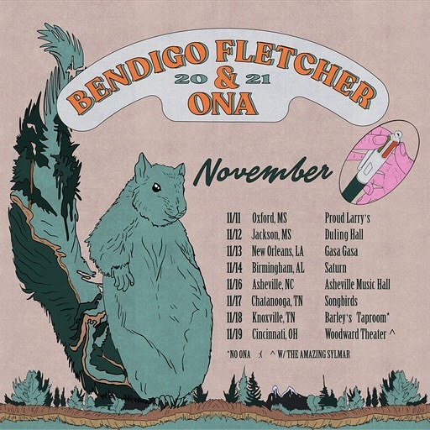

**Bendigo Fletcher** have announced additional US tour dates in support of their forthcoming debut album *Fits of Laughter.*This November, the band will embark on a run of co-headline shows with Ona and Sylmar. Tickets for all dates are on sale now [HERE](https://nam04.safelinks.protection.outlook.com/?url=https%3A%2F%2Fwww.bendigofletcher.com%2F&data=04%7C01%7CSydneyWorden%40elektra.com%7C43b5d0facf8948b3903508d951e3736e%7C8367939002ec4ba1ad3d69da3fdd637e%7C0%7C0%7C637630859609613679%7CUnknown%7CTWFpbGZsb3d8eyJWIjoiMC4wLjAwMDAiLCJQIjoiV2luMzIiLCJBTiI6Ik1haWwiLCJXVCI6Mn0%3D%7C1000&sdata=vDgOnOOfEyTCO20ATuaFY3jl33jFhFSK%2B0MK2fAraAc%3D&reserved=0). *Fits of Laughter*is due for release on August 13, 2021 via Elektra Records and is available for pre-order now [HERE](https://nam04.safelinks.protection.outlook.com/?url=http%3A%2F%2Fbendigofletcher.lnk.to%2Ffitsoflaughter&data=04%7C01%7CSydneyWorden%40elektra.com%7C43b5d0facf8948b3903508d951e3736e%7C8367939002ec4ba1ad3d69da3fdd637e%7C0%7C0%7C637630859609613679%7CUnknown%7CTWFpbGZsb3d8eyJWIjoiMC4wLjAwMDAiLCJQIjoiV2luMzIiLCJBTiI6Ik1haWwiLCJXVCI6Mn0%3D%7C1000&sdata=YIZ2liVpgb8aHmfwZt5s9%2BLAwLVRvEMDnpMxOJ1P%2F9o%3D&reserved=0). Watch the band perform the album’s latest track “Astro Pup” live from Louisville, KY’s Blackacre Farm [HERE](https://nam04.safelinks.protection.outlook.com/?url=https%3A%2F%2Fyoutu.be%2F1oOJckAP13w&data=04%7C01%7CSydneyWorden%40elektra.com%7C43b5d0facf8948b3903508d951e3736e%7C8367939002ec4ba1ad3d69da3fdd637e%7C0%7C0%7C637630859609623678%7CUnknown%7CTWFpbGZsb3d8eyJWIjoiMC4wLjAwMDAiLCJQIjoiV2luMzIiLCJBTiI6Ik1haWwiLCJXVCI6Mn0%3D%7C1000&sdata=U1jbPOVRMeTY6WqDB90bAJcKbt3%2Bvz%2ByErivvVgencY%3D&reserved=0).

This Summer, Bendigo Fletcher will return to the road for a run of headline shows and festival appearances. In the Fall and Winter, the band will support labelmate Anderson East on both legs of his Maybe We Never Die Tour of North America. The 22-city trek kicks off on October 21, 2021 with two nights at Los Angeles, CA’s famed Troubadour, and wraps on February 02, 2022 at Toronto, Canada’s Danforth Music Hall. A complete list of live dates and ticket information can be found [HERE](https://nam04.safelinks.protection.outlook.com/?url=https%3A%2F%2Fwww.bendigofletcher.com%2F&data=04%7C01%7CSydneyWorden%40elektra.com%7C43b5d0facf8948b3903508d951e3736e%7C8367939002ec4ba1ad3d69da3fdd637e%7C0%7C0%7C637630859609623678%7CUnknown%7CTWFpbGZsb3d8eyJWIjoiMC4wLjAwMDAiLCJQIjoiV2luMzIiLCJBTiI6Ik1haWwiLCJXVCI6Mn0%3D%7C1000&sdata=QLVh8f7mJhQhomzcDd7tEIuJGGrSgkzVUjXseVcHFGI%3D&reserved=0).

Bendigo Fletcher announced their Elektra Records signing in an exclusive interview with *American Songwriter*, and previewed *Fits of Laughter* with the release of lead single “[Evergreen](https://nam04.safelinks.protection.outlook.com/?url=https%3A%2F%2Fbendigo.lnk.to%2Fevergreen&data=04%7C01%7CSydneyWorden%40elektra.com%7C43b5d0facf8948b3903508d951e3736e%7C8367939002ec4ba1ad3d69da3fdd637e%7C0%7C0%7C637630859609633674%7CUnknown%7CTWFpbGZsb3d8eyJWIjoiMC4wLjAwMDAiLCJQIjoiV2luMzIiLCJBTiI6Ik1haWwiLCJXVCI6Mn0%3D%7C1000&sdata=EW5K4ZK4fBPikJKgCYav3de9yw62wZr%2FUt61ft2XOpo%3D&reserved=0)” earlier this year. In May, the band returned with the album’s groove-heavy opener “[Sugar in the Creek](https://nam04.safelinks.protection.outlook.com/?url=https%3A%2F%2Fbendigofletcher.lnk.to%2Fsugarinthecreek&data=04%7C01%7CSydneyWorden%40elektra.com%7C43b5d0facf8948b3903508d951e3736e%7C8367939002ec4ba1ad3d69da3fdd637e%7C0%7C0%7C637630859609633674%7CUnknown%7CTWFpbGZsb3d8eyJWIjoiMC4wLjAwMDAiLCJQIjoiV2luMzIiLCJBTiI6Ik1haWwiLCJXVCI6Mn0%3D%7C1000&sdata=sgcNg4eh0YC0jyhZI2KCOlIs2nViqRXYAdcTfHf0xsA%3D&reserved=0)” and an accompanying animated [music video](https://nam04.safelinks.protection.outlook.com/?url=https%3A%2F%2Fyoutu.be%2FkP9RJnmniDU&data=04%7C01%7CSydneyWorden%40elektra.com%7C43b5d0facf8948b3903508d951e3736e%7C8367939002ec4ba1ad3d69da3fdd637e%7C0%7C0%7C637630859609643666%7CUnknown%7CTWFpbGZsb3d8eyJWIjoiMC4wLjAwMDAiLCJQIjoiV2luMzIiLCJBTiI6Ik1haWwiLCJXVCI6Mn0%3D%7C1000&sdata=%2B%2F%2FJoDm1ycOpSFro0QplcXuWWU4ZQsz7%2FfsXCCt7jjg%3D&reserved=0). Last month, they unveiled the album’s latest track "[Astro Pup](https://nam04.safelinks.protection.outlook.com/?url=https%3A%2F%2Fwww.youtube.com%2Fwatch%3Fv%3Dmm85lPeevM8&data=04%7C01%7CSydneyWorden%40elektra.com%7C43b5d0facf8948b3903508d951e3736e%7C8367939002ec4ba1ad3d69da3fdd637e%7C0%7C0%7C637630859609643666%7CUnknown%7CTWFpbGZsb3d8eyJWIjoiMC4wLjAwMDAiLCJQIjoiV2luMzIiLCJBTiI6Ik1haWwiLCJXVCI6Mn0%3D%7C1000&sdata=MUEWvfdUx3Nlqw9TacoflJiVGsT6MbQftH0mEctI48g%3D&reserved=0)". The album’s early releases have been praised as “somewhere between the post-Woodstock folk scene of the ‘70s and that decade’s burgeoning hard rock movement” (*FLOOD Magazine),*and “denser psych-rock with some remaining elements of Bendigo Fletcher’s drifting folk-Americana roots” (*American Songwriter).*Additionally, *The Bluegrass Situation* premiered a live video of the band performing “Sugar In The Creek”. Watch [HERE](https://nam04.safelinks.protection.outlook.com/?url=https%3A%2F%2Fthebluegrasssituation.com%2Fread%2Fwatch-bendigo-fletcher-sugar-in-the-creek-blackacre-barn-session%2F&data=04%7C01%7CSydneyWorden%40elektra.com%7C43b5d0facf8948b3903508d951e3736e%7C8367939002ec4ba1ad3d69da3fdd637e%7C0%7C0%7C637630859609653666%7CUnknown%7CTWFpbGZsb3d8eyJWIjoiMC4wLjAwMDAiLCJQIjoiV2luMzIiLCJBTiI6Ik1haWwiLCJXVCI6Mn0%3D%7C1000&sdata=uSolqwhwtbA1MYKmn9tC1LGNsUv0fpD7f8dOsxWGnWs%3D&reserved=0).

Throughout *Fits of Laughter,*frontman Ryan Anderson crafts the patchwork poetry of his lyrics by serenely observing the world around him. When matched with the band’s gorgeous collision of country and folk-rock and dreamy psychedelia, the result is story-songs graced with raw humanity, wildly offbeat humor, and a transcendent sense of wonder. For help in forging the album’s ragged elegance, Bendigo Fletcher worked with producer Ken Coomer, laying down the album in nine frenetic days. The albumbears an undeniable immediacy, thanks in part to the band’s decision to limit the tracklist to eight essential songs (a move largely inspired by extraordinarily lean and iconic albums like Television’s *Marquee Moon*).

*Fits of Laughter* follows a trio of independent EPs that quietly amassed millions of streams and earned praise from *Pop Matters*, *Atwood Magazine*, and more. Converting audiences to fans on the road, Bendigo Fletcher has supported Mt. Joy, Nathaniel Rateliff, Rayland Baxter, Caamp, and Hiss Golden Messenger on tour. Bendigo Fletcher is: Ryan Anderson (lead vocals, guitar, banjo) - Andrew Shupert (backing vocals, lead guitar) - Evan Wagner (backing vocals, keys, guitar, auxiliary percussion) - Conner Powell (bass) - Chris Weis (drums).

**Bendigo Fletcher Tour Dates**

**Headline Shows and Festival Appearances**

August 08, 2021 - St. Charles, IA - Hinterland Music Festival^

August 25, 2021 - Indianapolis, IN - Hi-Fi#

August 26, 2021 - St. Louis, MO - Blueberry Hill*

August 27, 2021 - Chicago, IL - Schubas#

August 28, 2021 - Lexington, KY - Railbird Music Festival^

November 11, 2021 - Oxford, MS - Proud Larry’s*

November 12, 2021 - Jackson, MS - Duling Hall*

November 13, 2021 - New Orleans, LA - Gasa Gasa*

November 14, 2021 - Birmingham, AL - Saturn*

November 16, 2021 - Asheville, NC - Asheville Music Hall*

November 17, 2021 - Chattanooga, TN - Songbirds*

November 18, 2021 - Knoxville, TN - Barley’s Taproom*

November 19, 2021 - Cincinnati, OH - The Woodward+

^festival appearance

#headline show

*co-headline with ONA

+co-headline with Sylmar

**Supporting Anderson East**

October 21, 2021 - Los Angeles, CA - Troubadour

October 22, 2021 - Los Angeles, CA - Troubadour

October 23, 2021 - San Diego, CA - Observatory North Park

October 24, 2021 - San Francisco, CA - The Fillmore

October 26, 2021 - Crystal Bay, NV - Crystal Bay Casino

October 28, 2021 - Portland, OR - Roseland Theater

October 29, 2021 - Eugene, OR - WOW Hall

October 30, 2021 - Seattle, WA - The Showbox

October 31, 2021 - Vancouver, Canada - Rickshaw Theatre

November 02, 2021 - Boise, ID - Knitting Factory Concert House

November 03, 2021 - Salt Lake City, UT - The Commonwealth Room

November 05, 2021 - Englewood, CO - Gothic Theatre

January 13, 2022 - Atlanta, GA - Variety Playhouse

January 14, 2022 - Charlotte, NC - The Fillmore Charlotte

January 15, 2022 - Raleigh, NC - Lincoln Theatre

January 18, 2022 - Washington, DC - 9:30 Club

January 21, 2022 - New York, NY - Webster Hall

January 22, 2022 - Philadelphia, PA - Union Transfer

January 23, 2022 - Charlottesville, VA - Jefferson Theater

January 25, 2022 - South Burlington, VT - Higher Ground

January 26, 2022 - Portland, ME - State Theatre

January 28, 2022 - Boston, MA - Paradise Rock Club

February 01, 2022 - Millvale, PA - Mr Small’s Theatre

February 02, 2022 - Toronto, Canada - The Danforth Music Hall

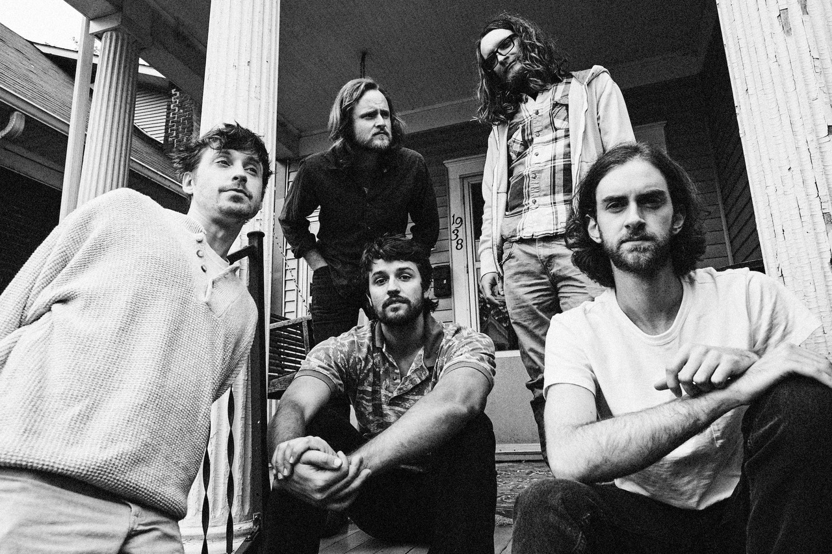

*Photo credit: Jimmy Fontaine*

[BendigoFletcher.com](https://nam04.safelinks.protection.outlook.com/?url=http%3A%2F%2Fbendigofletcher.com%2F&data=04%7C01%7CSydneyWorden%40elektra.com%7C43b5d0facf8948b3903508d951e3736e%7C8367939002ec4ba1ad3d69da3fdd637e%7C0%7C0%7C637630859609653666%7CUnknown%7CTWFpbGZsb3d8eyJWIjoiMC4wLjAwMDAiLCJQIjoiV2luMzIiLCJBTiI6Ik1haWwiLCJXVCI6Mn0%3D%7C1000&sdata=JNMv586HHRwFsG8h1L6ElNla5nFIv7kpG%2BbjdmPt4JA%3D&reserved=0)

[Facebook](https://nam04.safelinks.protection.outlook.com/?url=https%3A%2F%2Fwww.facebook.com%2Fbendigofletcher%2F&data=04%7C01%7CSydneyWorden%40elektra.com%7C43b5d0facf8948b3903508d951e3736e%7C8367939002ec4ba1ad3d69da3fdd637e%7C0%7C0%7C637630859609663654%7CUnknown%7CTWFpbGZsb3d8eyJWIjoiMC4wLjAwMDAiLCJQIjoiV2luMzIiLCJBTiI6Ik1haWwiLCJXVCI6Mn0%3D%7C1000&sdata=gqSmf0PMTwq2ODXKfeZP9uRzQdpxSUvbha3UFenu2pQ%3D&reserved=0) | [Instagram](https://nam04.safelinks.protection.outlook.com/?url=https%3A%2F%2Fwww.instagram.com%2Fbendigofletcher%2F%3Fhl%3Den&data=04%7C01%7CSydneyWorden%40elektra.com%7C43b5d0facf8948b3903508d951e3736e%7C8367939002ec4ba1ad3d69da3fdd637e%7C0%7C0%7C637630859609663654%7CUnknown%7CTWFpbGZsb3d8eyJWIjoiMC4wLjAwMDAiLCJQIjoiV2luMzIiLCJBTiI6Ik1haWwiLCJXVCI6Mn0%3D%7C1000&sdata=N4Vm282qcwU4GCsER%2BOOJ02up476iZmP8u9mA9e%2FoOg%3D&reserved=0) | [Twitter](https://nam04.safelinks.protection.outlook.com/?url=https%3A%2F%2Ftwitter.com%2Fbendigofletcher%3Flang%3Den&data=04%7C01%7CSydneyWorden%40elektra.com%7C43b5d0facf8948b3903508d951e3736e%7C8367939002ec4ba1ad3d69da3fdd637e%7C0%7C0%7C637630859609673649%7CUnknown%7CTWFpbGZsb3d8eyJWIjoiMC4wLjAwMDAiLCJQIjoiV2luMzIiLCJBTiI6Ik1haWwiLCJXVCI6Mn0%3D%7C1000&sdata=bPpbNgxQLFXPqelL9WgjUt6e%2BKh9hTd0%2F1uhUHOIMUE%3D&reserved=0) | [YouTube](https://nam04.safelinks.protection.outlook.com/?url=https%3A%2F%2Fwww.youtube.com%2Fchannel%2FUCqWvWwv7K8kq3PZnygVG1BA&data=04%7C01%7CSydneyWorden%40elektra.com%7C43b5d0facf8948b3903508d951e3736e%7C8367939002ec4ba1ad3d69da3fdd637e%7C0%7C0%7C637630859609673649%7CUnknown%7CTWFpbGZsb3d8eyJWIjoiMC4wLjAwMDAiLCJQIjoiV2luMzIiLCJBTiI6Ik1haWwiLCJXVCI6Mn0%3D%7C1000&sdata=pvDIC06m3YaP0ZuaI8RNayJTxRFBLAu6amcK%2FsdzNjg%3D&reserved=0)

**Press contact:**

Collin Citron | [CollinCitron@elektra.com](mailto:CollinCitron@elektra.com)