FOR IMMEDIATE RELEASE
May 13, 2021

BENDIGO FLETCHER ANNOUNCES DEBUT ALBUM FITS OF LAUGHTER
AVAILABLE AUGUST 13 ON ELEKTRA RECORDS - PREORDER HERE

BAND SHARES NEW SINGLE AND VIDEO “SUGAR IN THE CREEK”
LISTEN AND WATCH HERE

Photo credit: Jimmy Fontaine

Louisville, KY’s Bendigo Fletcher have announced they will release their debut studio album Fits of Laughter on August 13, 2021 via Elektra Records. The album is available for pre-order starting today HERE. Merch bundles and limited edition colored vinyl are available exclusively through the band’s online store HERE.

Bendigo Fletcher has also released the album’s groove-heavy opening track “Sugar in the Creek”. The song is available to stream and download now HERE. Earlier today, FLOOD Magazine premiered an accompanying animated music video for the song. Watch it HERE.

On Fits of Laughter, frontman Ryan Anderson crafts the patchwork poetry of his lyrics by serenely observing the world around him. When matched with the band’s gorgeously jangly collision of country and folk-rock and dreamy psychedelia, the result is story-songs graced with raw humanity, wildly offbeat humor, and a transcendent sense of wonder. For help in forging the album’s ragged elegance, Bendigo Fletcher worked with producer Ken Coomer (original drummer for Wilco and Uncle Tupelo), laying down the album in nine frenetic days. The album bears an undeniable immediacy, thanks in part to the band’s decision to limit the tracklist to eight essential songs (a move largely inspired by extraordinarily lean and iconic albums like Television’s Marquee Moon).

Referring to Fits of Laughter as a coming-of-age album, Anderson also examines a more internal conflict throughout the songs, including his choice to abandon his medical-school aspirations in favor of pursuing a career in music. “The title’s really about the spectrum of emotions I’ve felt on the way to finding what makes me feel like I’m living truthfully, rather than holding onto what I think other people’s expectations are of me,” Anderson shares. “It’s a phrase that bridges all of those emotions—everything from joy to hysteria.”

Bendigo Fletcher recently announced their Elektra Records signing in an exclusive interview with American Songwriter. The band previewed Fits of Laughter with the March release of lead single “Evergreen”. Watch them perform the track live from Louisville, KY’s Blackacre Farm HERE.

Fits of Laughter follows a trio of independent EPs that quietly amassed millions of streams and earned praise from Pop Matters, Atwood Magazine, and more. Converting audiences to fans on the road, Bendigo Fletcher has supported Mt. Joy, Nathaniel Rateliff, Rayland Baxter, Caamp, and Hiss Golden Messenger on tour. Bendigo Fletcher is: Ryan Anderson (lead vocals, guitar, banjo) - Andrew Shupert (backing vocals, lead guitar) - Evan Wagner (backing vocals, keys, guitar, auxiliary percussion) - Conner Powell (bass) - Chris Weis (drums).

Fits of Laughter Tracklisting
1. Sugar in the Creek
2. Birding
3. Donkey Boy Blues
4. Buffalo Rodeo
5. Evergreen
6. Astro Pup
7. Retail Lord
8. Ulterior Motives

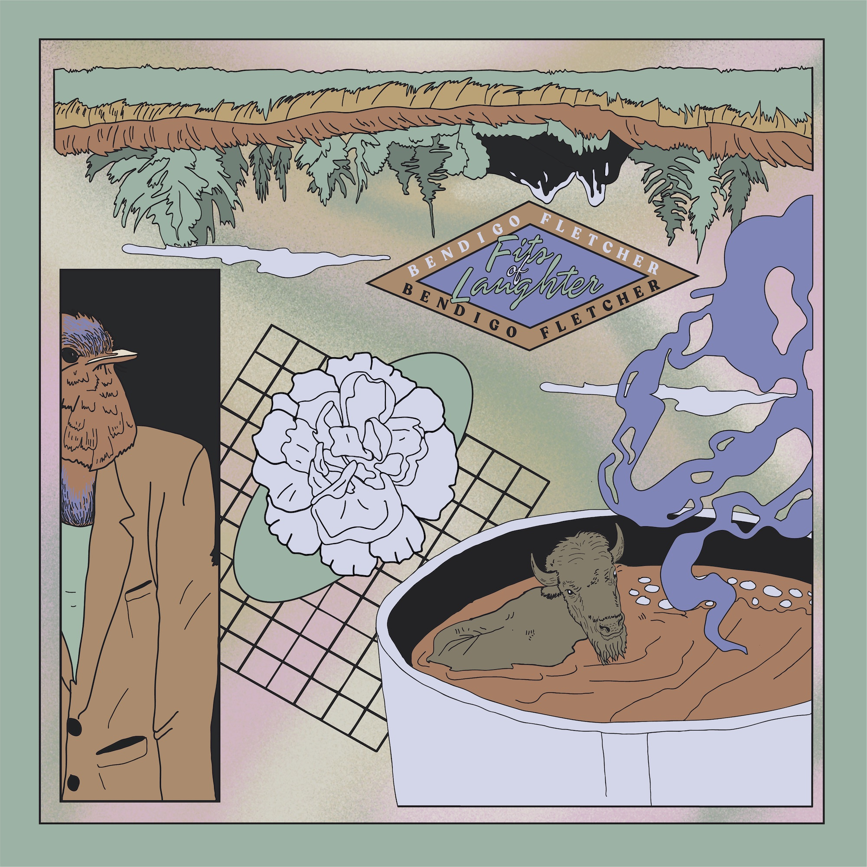

BendigoFletcher.com
Facebook | Instagram | Twitter | YouTube

Press contact:
Collin Citron | CollinCitron@elektra.com

