FOR IMMEDIATE RELEASE

June 24, 2021

**BENDIGO FLETCHER RELEASE NEW TRACK “ASTRO PUP” FROM FORTHCOMING DEBUT ALBUM *FITS OF LAUGHTER***

**LISTEN**[**HERE**](https://nam04.safelinks.protection.outlook.com/?url=https%3A%2F%2Fbendigofletcher.lnk.to%2Fastropup&data=04%7C01%7CSydneyWorden%40elektra.com%7C4613e8c2e9124ff4fd3008d9371896f3%7C8367939002ec4ba1ad3d69da3fdd637e%7C0%7C0%7C637601401032238904%7CUnknown%7CTWFpbGZsb3d8eyJWIjoiMC4wLjAwMDAiLCJQIjoiV2luMzIiLCJBTiI6Ik1haWwiLCJXVCI6Mn0%3D%7C1000&sdata=guqBzmb3XJOr9%2BKYZ%2BiONACgIGL9gx7%2BMMtBrK04VS4%3D&reserved=0)**/ PREORDER THE ALBUM**[**HERE**](https://nam04.safelinks.protection.outlook.com/?url=http%3A%2F%2Fbendigofletcher.lnk.to%2Ffitsoflaughter&data=04%7C01%7CSydneyWorden%40elektra.com%7C4613e8c2e9124ff4fd3008d9371896f3%7C8367939002ec4ba1ad3d69da3fdd637e%7C0%7C0%7C637601401032248896%7CUnknown%7CTWFpbGZsb3d8eyJWIjoiMC4wLjAwMDAiLCJQIjoiV2luMzIiLCJBTiI6Ik1haWwiLCJXVCI6Mn0%3D%7C1000&sdata=95EuVkdY4DxByCiiYsVandTnsv9IORwT1yAVDwfkVCc%3D&reserved=0)

**BAND TO SUPPORT ANDERSON EAST ON UPCOMING NORTH AMERICAN TOUR**

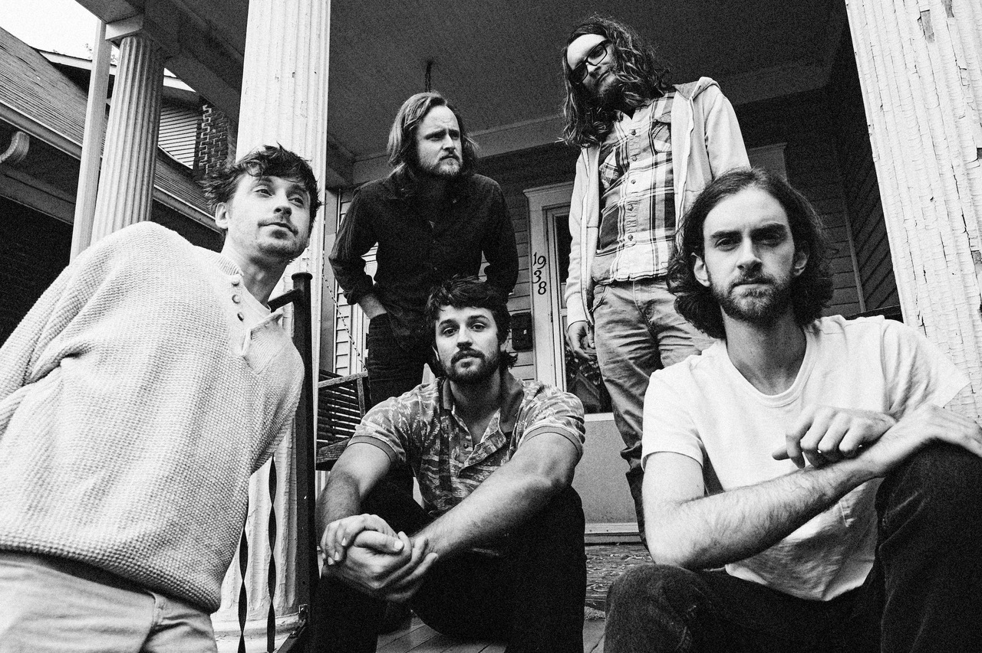

*Photo credit: Jimmy Fontaine*

Louisville, KY’s **Bendigo Fletcher** have unveiled “**Astro Pup**”, the third track off their forthcoming debut album *Fits of Laughter.*The song is available to stream and download starting today [HERE](https://nam04.safelinks.protection.outlook.com/?url=https%3A%2F%2Fbendigofletcher.lnk.to%2Fastropup&data=04%7C01%7CSydneyWorden%40elektra.com%7C4613e8c2e9124ff4fd3008d9371896f3%7C8367939002ec4ba1ad3d69da3fdd637e%7C0%7C0%7C637601401032258890%7CUnknown%7CTWFpbGZsb3d8eyJWIjoiMC4wLjAwMDAiLCJQIjoiV2luMzIiLCJBTiI6Ik1haWwiLCJXVCI6Mn0%3D%7C1000&sdata=ILCPH4BUtSbQBSXOUBdl2kLCBParAiUFWXD587U32rs%3D&reserved=0). Watch a lyric video for the song [HERE](https://nam04.safelinks.protection.outlook.com/?url=https%3A%2F%2Fyoutu.be%2Fmm85lPeevM8&data=04%7C01%7CSydneyWorden%40elektra.com%7C4613e8c2e9124ff4fd3008d9371896f3%7C8367939002ec4ba1ad3d69da3fdd637e%7C0%7C0%7C637601401032258890%7CUnknown%7CTWFpbGZsb3d8eyJWIjoiMC4wLjAwMDAiLCJQIjoiV2luMzIiLCJBTiI6Ik1haWwiLCJXVCI6Mn0%3D%7C1000&sdata=INzlHDZwRA6SnK04yAWRhKYnJDrNBsm1lp0C%2Bp9dVvU%3D&reserved=0). *Fits of Laughter*is due for release on August 13, 2021 via Elektra Records and is available for pre-order now [HERE](https://nam04.safelinks.protection.outlook.com/?url=http%3A%2F%2Fbendigofletcher.lnk.to%2Ffitsoflaughter&data=04%7C01%7CSydneyWorden%40elektra.com%7C4613e8c2e9124ff4fd3008d9371896f3%7C8367939002ec4ba1ad3d69da3fdd637e%7C0%7C0%7C637601401032268882%7CUnknown%7CTWFpbGZsb3d8eyJWIjoiMC4wLjAwMDAiLCJQIjoiV2luMzIiLCJBTiI6Ik1haWwiLCJXVCI6Mn0%3D%7C1000&sdata=L9lH1m0v%2BR2lwb2cHEVq7SLXz9I6DQpey1bhT9nwOVw%3D&reserved=0). Merch bundles and limited edition colored vinyl are available exclusively through the band’s online store [HERE](https://nam04.safelinks.protection.outlook.com/?url=https%3A%2F%2Fbendigo-fletcher.myshopify.com%2F&data=04%7C01%7CSydneyWorden%40elektra.com%7C4613e8c2e9124ff4fd3008d9371896f3%7C8367939002ec4ba1ad3d69da3fdd637e%7C0%7C0%7C637601401032268882%7CUnknown%7CTWFpbGZsb3d8eyJWIjoiMC4wLjAwMDAiLCJQIjoiV2luMzIiLCJBTiI6Ik1haWwiLCJXVCI6Mn0%3D%7C1000&sdata=Ixa9IJFs6KqCZxhYZJZwnbZTtVsennY5EkmO%2FaDygAE%3D&reserved=0).

On “Astro Pup,” the band delivers a heartbreak anthem spiked with heavenly harmonies and radiant banjo melodies. As Bendigo Fletcher’s first time working with an outside producer (Ken Coomer, original drummer for Wilco and Uncle Tupelo), *Fits of Laughter* draws much of its freewheeling energy from the deliberately unfussy nature of their recording sessions. “Going into working with Ken, we felt confident that we wanted to retain the jangly sweetness of the music we’ve made in the past,” shares frontman Ryan Anderson. “There’s loose ends and missed beats that we didn’t intend to make happen, but those moments always feel really special when they’re resolved—it sounds like a band actually playing together.”

This Summer, Bendigo Fletcher will return to the road for a run of headline shows and festival appearances. In the Fall and Winter, the band will support labelmate Anderson East on both legs of his Maybe We Never Die Tour of North America. The 22-city trek kicks off on October 21, 2021 with two nights at Los Angeles, CA’s famed Troubadour, and wraps on February 02, 2022 at Toronto, Canada’s Danforth Music Hall. A complete list of live dates and ticket information can be found [HERE](https://nam04.safelinks.protection.outlook.com/?url=https%3A%2F%2Fwww.bendigofletcher.com%2F&data=04%7C01%7CSydneyWorden%40elektra.com%7C4613e8c2e9124ff4fd3008d9371896f3%7C8367939002ec4ba1ad3d69da3fdd637e%7C0%7C0%7C637601401032278879%7CUnknown%7CTWFpbGZsb3d8eyJWIjoiMC4wLjAwMDAiLCJQIjoiV2luMzIiLCJBTiI6Ik1haWwiLCJXVCI6Mn0%3D%7C1000&sdata=d6BZkexiSdKghad%2FFhWRcwzJ2VSUAwr%2BUjCk8MBNovI%3D&reserved=0).

Bendigo Fletcher announced their Elektra Records signing in an exclusive interview with *American Songwriter*, and previewed *Fits of Laughter* with the release of lead single “[Evergreen](https://nam04.safelinks.protection.outlook.com/?url=https%3A%2F%2Fbendigo.lnk.to%2Fevergreen&data=04%7C01%7CSydneyWorden%40elektra.com%7C4613e8c2e9124ff4fd3008d9371896f3%7C8367939002ec4ba1ad3d69da3fdd637e%7C0%7C0%7C637601401032278879%7CUnknown%7CTWFpbGZsb3d8eyJWIjoiMC4wLjAwMDAiLCJQIjoiV2luMzIiLCJBTiI6Ik1haWwiLCJXVCI6Mn0%3D%7C1000&sdata=OeTkte%2FBp8O%2BKZo6QLgNTXeeB7iBI13lZc7EzGjk%2F%2Fg%3D&reserved=0)” earlier this year. In May, the band returned with the album’s groove-heavy opener “[Sugar in the Creek](https://nam04.safelinks.protection.outlook.com/?url=https%3A%2F%2Fbendigofletcher.lnk.to%2Fsugarinthecreek&data=04%7C01%7CSydneyWorden%40elektra.com%7C4613e8c2e9124ff4fd3008d9371896f3%7C8367939002ec4ba1ad3d69da3fdd637e%7C0%7C0%7C637601401032288872%7CUnknown%7CTWFpbGZsb3d8eyJWIjoiMC4wLjAwMDAiLCJQIjoiV2luMzIiLCJBTiI6Ik1haWwiLCJXVCI6Mn0%3D%7C1000&sdata=pT7KQr33H9GHeTgsHmxi0dyVm%2Fj1tfX7TdeAbyCg120%3D&reserved=0)” and an accompanying animated [music video](https://nam04.safelinks.protection.outlook.com/?url=https%3A%2F%2Fyoutu.be%2FkP9RJnmniDU&data=04%7C01%7CSydneyWorden%40elektra.com%7C4613e8c2e9124ff4fd3008d9371896f3%7C8367939002ec4ba1ad3d69da3fdd637e%7C0%7C0%7C637601401032288872%7CUnknown%7CTWFpbGZsb3d8eyJWIjoiMC4wLjAwMDAiLCJQIjoiV2luMzIiLCJBTiI6Ik1haWwiLCJXVCI6Mn0%3D%7C1000&sdata=8aRpKK5S3XAnrGw2nllh4QepEXzhhKPHxx9PdmmsG3Q%3D&reserved=0). The album’s early tracks have been praised as “somewhere between the post-Woodstock folk scene of the ‘70s and that decade’s burgeoning hard rock movement” (*FLOOD Magazine),*and “denser psych-rock with some remaining elements of Bendigo Fletcher’s drifting folk-Americana roots” (*American Songwriter).*Earlier this month, *The Bluegrass Situation* premiered a live video of the band performing “Sugar In The Creek” at Louisville, KY’s Blackacre Farm. Watch it [HERE](https://nam04.safelinks.protection.outlook.com/?url=https%3A%2F%2Fthebluegrasssituation.com%2Fread%2Fwatch-bendigo-fletcher-sugar-in-the-creek-blackacre-barn-session%2F&data=04%7C01%7CSydneyWorden%40elektra.com%7C4613e8c2e9124ff4fd3008d9371896f3%7C8367939002ec4ba1ad3d69da3fdd637e%7C0%7C0%7C637601401032298867%7CUnknown%7CTWFpbGZsb3d8eyJWIjoiMC4wLjAwMDAiLCJQIjoiV2luMzIiLCJBTiI6Ik1haWwiLCJXVCI6Mn0%3D%7C1000&sdata=3hHruFMHEUJ2hKYGdFEztMcAR5XNhIo5HfSTk0VWR34%3D&reserved=0).

Throughout *Fits of Laughter,*frontman Ryan Anderson crafts the patchwork poetry of his lyrics by serenely observing the world around him. When matched with the band’s gorgeous collision of country and folk-rock and dreamy psychedelia, the result is story-songs graced with raw humanity, wildly offbeat humor, and a transcendent sense of wonder. For help in forging the album’s ragged elegance, Bendigo Fletcher worked with producer Ken Coomer, laying down the album in nine frenetic days. The albumbears an undeniable immediacy, thanks in part to the band’s decision to limit the tracklist to eight essential songs (a move largely inspired by extraordinarily lean and iconic albums like Television’s *Marquee Moon*).

*Fits of Laughter* follows a trio of independent EPs that quietly amassed millions of streams and earned praise from *Pop Matters*, *Atwood Magazine*, and more. Converting audiences to fans on the road, Bendigo Fletcher has supported Mt. Joy, Nathaniel Rateliff, Rayland Baxter, Caamp, and Hiss Golden Messenger on tour. Bendigo Fletcher is: Ryan Anderson (lead vocals, guitar, banjo) - Andrew Shupert (backing vocals, lead guitar) - Evan Wagner (backing vocals, keys, guitar, auxiliary percussion) - Conner Powell (bass) - Chris Weis (drums).

**Bendigo Fletcher Tour Dates**

July 15, 2021 - Louisville, KY - High Horse#

August 08, 2021 - St. Charles, IA - Hinterland Music Festival^

August 25, 2021 - Indianapolis, IN - Hi-Fi#

August 26, 2021 - St. Louis, MO - Blueberry Hill*

August 27, 2021 - Chicago, IL - Schubas#

August 28, 2021 - Lexington, KY - Railbird Music Festival^

October 21, 2021 - Los Angeles, CA - Troubadour*

October 22, 2021 - Los Angeles, CA - Troubadour*

October 23, 2021 - San Diego, CA - Observatory North Park*

October 24, 2021 - San Francisco, CA - The Fillmore*

October 26, 2021 - Crystal Bay, NV - Crystal Bay Casino*

October 28, 2021 - Portland, OR - Roseland Theater*

October 29, 2021 - Eugene, OR - WOW Hall*

October 30, 2021 - Seattle, WA - The Showbox*

October 31, 2021 - Vancouver, Canada - Rickshaw Theatre*

November 02, 2021 - Boise, ID - Knitting Factory Concert House*

November 03, 2021 - Salt Lake City, UT - The Commonwealth Room*

November 05, 2021 - Englewood, CO - Gothic Theatre*

January 13, 2022 - Atlanta, GA - Variety Playhouse*

January 14, 2022 - Charlotte, NC - The Fillmore Charlotte*

January 15, 2022 - Raleigh, NC - Lincoln Theatre*

January 18, 2022 - Washington, DC - 9:30 Club*

January 21, 2022 - New York, NY - Webster Hall*

January 22, 2022 - Philadelphia, PA - Union Transfer*

January 23, 2022 - Charlottesville, VA - Jefferson Theater*

January 25, 2022 - South Burlington, VT - Higher Ground*

January 26, 2022 - Portland, ME - State Theatre*

January 28, 2022 - Boston, MA - Paradise Rock Club*

February 01, 2022 - Millvale, PA - Mr Small’s Theatre*

February 02, 2022 - Toronto, Canada - The Danforth Music Hall*

#headline show

^festival appearance

*supporting Anderson East

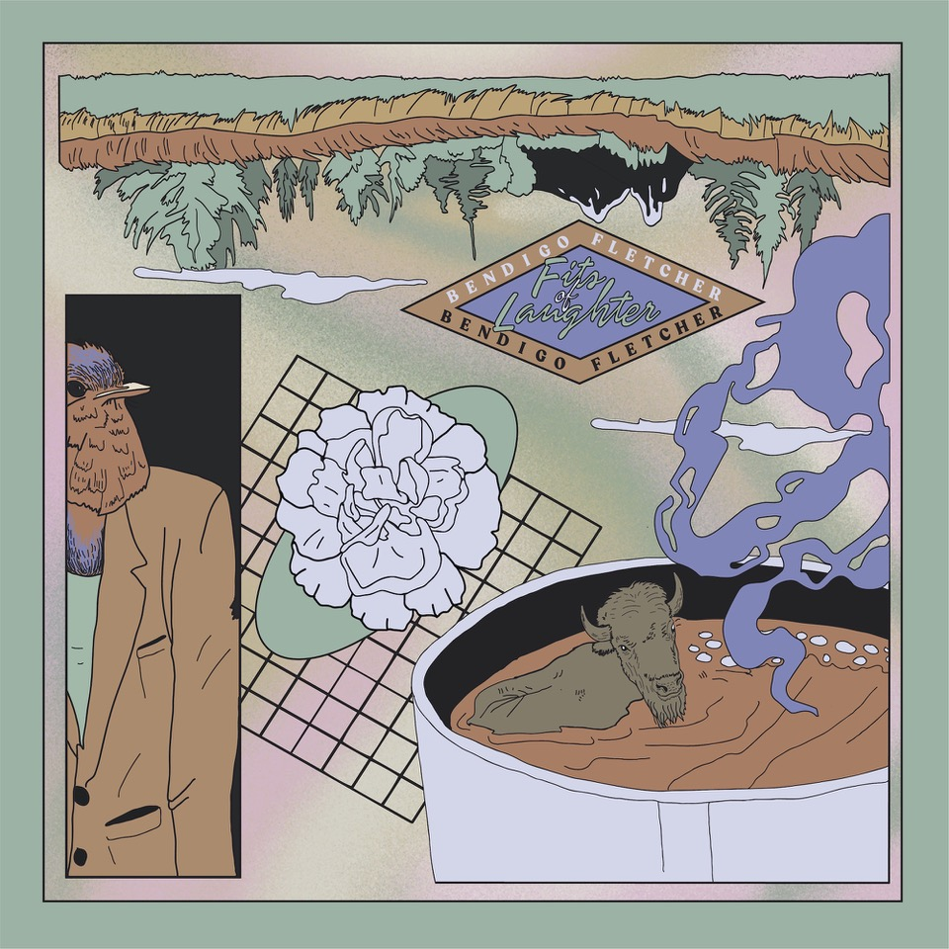

[BendigoFletcher.com](https://nam04.safelinks.protection.outlook.com/?url=http%3A%2F%2Fbendigofletcher.com%2F&data=04%7C01%7CSydneyWorden%40elektra.com%7C4613e8c2e9124ff4fd3008d9371896f3%7C8367939002ec4ba1ad3d69da3fdd637e%7C0%7C0%7C637601401032298867%7CUnknown%7CTWFpbGZsb3d8eyJWIjoiMC4wLjAwMDAiLCJQIjoiV2luMzIiLCJBTiI6Ik1haWwiLCJXVCI6Mn0%3D%7C1000&sdata=IabEyqark3poxAXfAOZaeZvr%2FVvcLryo7THSrePIGBY%3D&reserved=0)

[Facebook](https://nam04.safelinks.protection.outlook.com/?url=https%3A%2F%2Fwww.facebook.com%2Fbendigofletcher%2F&data=04%7C01%7CSydneyWorden%40elektra.com%7C4613e8c2e9124ff4fd3008d9371896f3%7C8367939002ec4ba1ad3d69da3fdd637e%7C0%7C0%7C637601401032308859%7CUnknown%7CTWFpbGZsb3d8eyJWIjoiMC4wLjAwMDAiLCJQIjoiV2luMzIiLCJBTiI6Ik1haWwiLCJXVCI6Mn0%3D%7C1000&sdata=wYx2fQ%2FAtQUTN1BVllhHhvQZ6ifkYLp3hqFSgCHmirw%3D&reserved=0) | [Instagram](https://nam04.safelinks.protection.outlook.com/?url=https%3A%2F%2Fwww.instagram.com%2Fbendigofletcher%2F%3Fhl%3Den&data=04%7C01%7CSydneyWorden%40elektra.com%7C4613e8c2e9124ff4fd3008d9371896f3%7C8367939002ec4ba1ad3d69da3fdd637e%7C0%7C0%7C637601401032308859%7CUnknown%7CTWFpbGZsb3d8eyJWIjoiMC4wLjAwMDAiLCJQIjoiV2luMzIiLCJBTiI6Ik1haWwiLCJXVCI6Mn0%3D%7C1000&sdata=1I2OCPmhyFJgyKYSzBLdBQTQhg8WVaJlBVBVQyKDWSM%3D&reserved=0) | [Twitter](https://nam04.safelinks.protection.outlook.com/?url=https%3A%2F%2Ftwitter.com%2Fbendigofletcher%3Flang%3Den&data=04%7C01%7CSydneyWorden%40elektra.com%7C4613e8c2e9124ff4fd3008d9371896f3%7C8367939002ec4ba1ad3d69da3fdd637e%7C0%7C0%7C637601401032318855%7CUnknown%7CTWFpbGZsb3d8eyJWIjoiMC4wLjAwMDAiLCJQIjoiV2luMzIiLCJBTiI6Ik1haWwiLCJXVCI6Mn0%3D%7C1000&sdata=QXHWioMx3SVt9V4lXtOgEzM2uGYMmvdfnYV%2BDrR9c%2BI%3D&reserved=0) | [YouTube](https://nam04.safelinks.protection.outlook.com/?url=https%3A%2F%2Fwww.youtube.com%2Fchannel%2FUCqWvWwv7K8kq3PZnygVG1BA&data=04%7C01%7CSydneyWorden%40elektra.com%7C4613e8c2e9124ff4fd3008d9371896f3%7C8367939002ec4ba1ad3d69da3fdd637e%7C0%7C0%7C637601401032318855%7CUnknown%7CTWFpbGZsb3d8eyJWIjoiMC4wLjAwMDAiLCJQIjoiV2luMzIiLCJBTiI6Ik1haWwiLCJXVCI6Mn0%3D%7C1000&sdata=sLo%2Bbbt2fYx%2BcyxO0eVcE72K0%2BvC4%2FbLEjVMLAFb8BU%3D&reserved=0)

**Press contact:**

Collin Citron | [CollinCitron@elektra.com](mailto:CollinCitron@elektra.com)