ANNA OF THE NORTH
RELEASES “DANDELION”
LISTEN HERE // WATCH HERE

+JOIN ANNA & GUS ON LOREM [SPOTIFY EXCLUSIVE] TODAY FROM 2-3PM PST+

+performing at Firefly Festival September 2022+
June 29, 2022 – Today, Anna of the North releases "Dandelion.” The hopeful track is as melodic as it is vulnerable. Comparing a previous love to the fleetingness of a dandelion in the wind, Anna conveys the loss and optimism that arrives when the person is right, but the timing is wrong.

Arriving on the heels of the Gus Dapperton collaboration “Meteorite,” the track continues Anna’s journey building a home of her own and inviting you for a visit. "Dandelion” introduces viewers to Anna’s living room, complete with her fluffy dog and thriving plants. Working hand in hand with Australian designer Montana Kitching to bring the room ‘to life,’ fans can expect to see more of Anna’s home alongside future music.

Speaking of the track Anna states “‘Dandelion; is a song about lost love. The kind of love that can’t stay for obvious reasons... Still there is hope that one day it’ll work out.”

Additionally, Gus Dapperton will join Anna on Lorem Life [a Spotify Live Exclusive] at 2pm PST for a chat with hosts Dev Lemons and Max Motley. Inspired by the Spotify playlist, Lorem Life is an extension of that ethos via live discussions about topics ranging from music, art and fashion, to environment and sustainability-- with the most exciting guests right at the center of these topics. Previous guests include Role Model, Wallows, BENEE, spill tab, and more. Check it out here.

With 500M+ streams under her belt, co-signs from Tyler The Creator, Dua Lipa, Alina Baraz, Rejjie Snow, Steve Lazy and more, Anna of the North is the pop star who has been hiding in plain sight.

Anna won a Norwegian Grammy Award (Spellemannprisen) for her music video "Dream Girl". Additionally, she had a track synced to a Global iPad Pro Commercial (+ 2 Netflix shows), 'opened' for Katy Perry, & performed at the first ever Zoomtopia. Her track "Dream Girl" was featured in the 3rd film in the trilogy 'To All The Boys...Always & Forever' - she's the only artist featured in all three films. All of her syncs became viral moments but the iPad Pro sync saw overnight success, and in less than a week Anna was charting on iTunes in over 30+ Countries, doubled her Daily Spotify Streams and saw an overall streaming increase of 187%. Recently, Anna has been on the reality TV show Hver Gang Vi Mötes. The show has broken more artists and resurrected more artist careers than any other media in any of the countries where it currently airs.
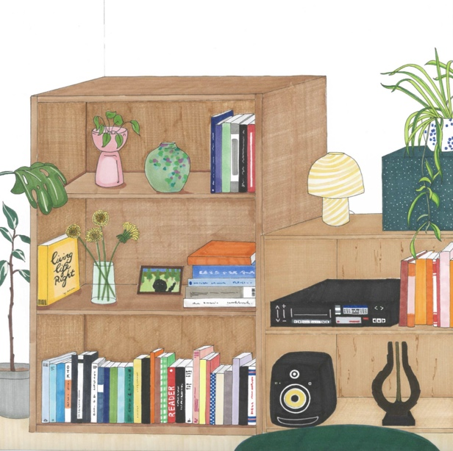
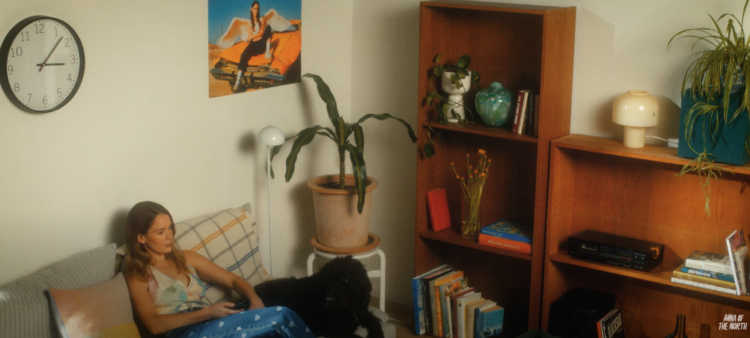
About Anna of the North
Anna of the North strikes an emotional chord regardless of continent, collaborator, or genre and her music has taken on an unexpected life of its own as it finds success in syncs. Few modern artists could appear as at home working with Tyler, the Creator (Anna lent her vocals to two tracks on ‘Flower Boy’ alongside Steve Lacy, Frank Ocean, and Rex Orange County) and Rejjie Snow as they are duetting with HONNE or playing with Anderson Paak. All of which has led Anna to where she finds herself in now; a pop star and a fearless young woman who is set to make 2022 her year.

