ALEC BENJAMIN NEW ALBUM (UN)COMMENTARY
AVAILABLE APRIL 15TH

“SHADOW OF MINE”
NEW SONG & VIDEO OUT NOW
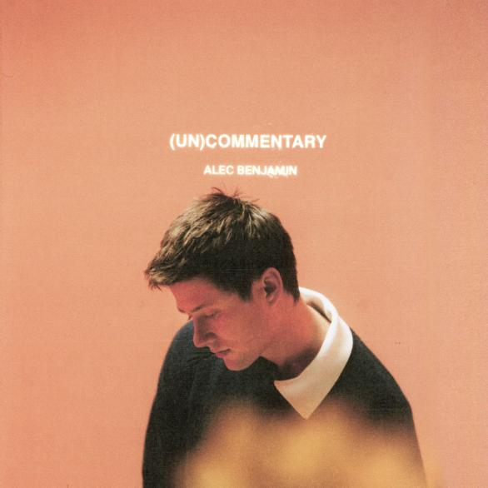

Critically acclaimed singer-songwriter Alec Benjamin has announced the release of his sophomore album (Un)Commentary out on April 15th via Elektra Records. The album will feature 13 tracks including the previously released “The Way You Felt,” “Older,” and “Shadow Of Mine,” out now with the accompanying music video directed by Gus Black (Phoebe Bridgers, Sheryl Crow). The song is a moody and mesmerizing piece that speaks to the futility of trying to outrun your demons. Alec observes, “A lot of the time you think your problems are the product of your environment, when in reality they exist inside you.” Listen to the track here and watch the video here.

(Un)Commentary came to life through a relentless questioning of the world around him: the pressures and disappointments of adulthood, the indignities of social-media addiction, existential anxiety and angst, and countless other manifestations of what he refers to as “raw human nature.”

“I think my generation has a lot of valid criticisms of everything that’s happening in our country and in the world right now,” says Alec of (Un)commentary’s essential narrative. “The question is: are we going to tear ourselves apart, or are we going to leave this place better than we found it?”

(Un)Commentary was produced by Sir Nolan (Kehlani, Selena Gomez), Sam de Jong (Lennon Stella, Gary Clark Jr.), and RØMANS (Mary J Blige, Khalid) and features writing collaborations with Dan Wilson (Adele, Leon Bridges), Charlie Puth (Justin Bieber, John Legend), Sam Roman (RØMANS) and Nolan Lambrosa (Sir Nolan) to name a few. Pre-order the album here.

Alec Benjamin will continue the 2nd leg of his North American tour this April with 19 additional headlining shows as well as his debut performances at the 2022 Coachella Valley Music and Arts Festival on April 17th and 24th. The 19-city trek kicks off on April 9th in Spokane, WA, and concludes on May 15th in Portland, ME. These new dates follow an already completed 1st leg of his 2021 tour that had Benjamin playing over 20 sold-out shows in cities like Philadelphia, Seattle, Boston, Denver, and Nashville to name a few. See below for a full list of tour dates, and purchase tickets at https://www.alecbenjamin.com/tour/.

Alec, who Paper magazine dubbed “a storyteller who’s mastered the art of turning everyday heartbreak into compelling pop songs,” has an already impressive resume which includes 4B+ global streams, 10M+ social media followers across his platforms, 70M+ in playlist reach, and 1B+ YouTube views on his channel. Following the successes of “Let Me Down Slowly” (Double-Platinum), “Water Fountain” (Platinum), and “Oh My God” (Gold), TIME hailed him as “a pop storyteller for the next generation.” Alec looks forward to continuing his retrospective run of new music into 2022.

Alec Benjamin Tour Dates

April 9 | Spokane, WA | Knitting Factory
April 10 | Boise, ID | Knitting Factory
April 13 | Eugene, OR | McDonald Theatre
April 17 | Palm Springs, CA | Coachella Valley Music & Arts Festival
April 19 | Las Vegas, NV | House of Blues
April 24 | Palm Springs, CA | Coachella Valley Music & Arts Festival
April 26 | Albuquerque, NM | El Rey Theater
April 28 | Oklahoma City, OK | Diamond Ballroom
April 29 | Kansas City, MO | The Truman
April 30 | St. Louis, MO | The Pageant
May 1 | Omaha, NE | The Admiral
May 3 | Madison, WI | The Sylvee
May 4 | Indianapolis, IN | Egyptian Room @ Old National Centre
May 5 | Cincinnati, OH | Bogarts
May 6 | Grand Rapids, MI | GLC Live at 20 Monroe
May 9 | Columbus, OH | Express Live!
May 10 | Pittsburgh, PA | Roxian Theatre
May 11 | Buffalo, NY | Town Ballroom
May 13 | South Burlington, VT | Higher Ground Ballroom
May 14 | Providence, RI | The Strand
May 15 | Portland, ME | State Theatre

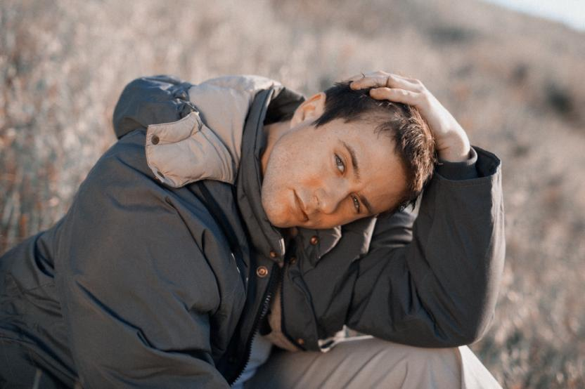

(Download high-res images here)
CONNECT:
Website | Facebook | Twitter | Instagram | YouTube

Alec Benjamin is distributed by Elektra Records and represented by Wasserman Music and Activist Artists Management.

