FOR IMMEDIATE RELEASE

SEPTEMBER 17, 2021

**ALEC BENJAMIN**

**“OLDER”**

**NEW SINGLE AND VIDEO OUT NOW**

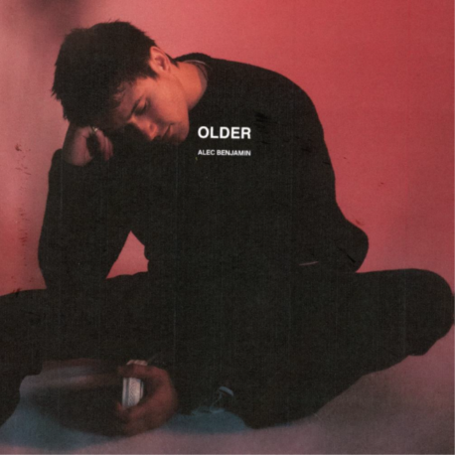

Multi-platinum, singer-songwriter, Alec Benjamin announces the release of his new single “Older” and its accompanying music video. The opening line of “Older,” “I’m not prepared for the future,” sets the tone for the track as Alec searches for answers behind the uncertainties of growing older. The music video for “Older”, directed by AJ Favicchio and Miles Cable, sees Alec and his childhood friends put their adult lives on hold and reunite to recreate fun moments from their past. A school bus transports the friends through their old stomping grounds, and we’re introduced to fun anecdotes from their very long friendship. Listen to “Older” [**HERE**](alecbenjamin.lnk.to/Older)and check out the new video [**HERE**](https://www.youtube.com/watch?v=XDhevwYp-g4).

Since his first release in 2018, Alec has received high praise by many critics and outlets. *TIME* Magazine calls Alec “… a Pop storyteller for the next generation.” *Paper* Magazine says about Alec, “He’s a storyteller who’s mastered the art of turning everyday heartbreak into compelling pop songs”. Over his career Alec has amassed 4B+ global streams, 10M+ social media followers across his platforms, 70M+ in playlist reach, two RIAA gold single certifications and 910M+ YouTube views on his channel. Alec’s first record ***These Two Windows* (listen** [**HERE**](https://open.spotify.com/album/3SzqS1H5dj8f450YhV9YbP?si=ov2DhpauRDGdD0_kuy-qGA&dl_branch=1&nd=1)**)*,*** *PEOPLE* proclaimed as, “…a major milestone”, consisting of the hit tracks, “Jesus In LA,” “Oh My God,” and “Mind Is A Prison”, reached half-a-billion streams during its first year of release.

Alec Benjamin kicked off his headlining, 26-show, North American Fall Tour on September 14th in Santa Cruz, CA and will conclude October 21st in Pomona, CA with support from Anson Seabra along the way. Due to the overwhelming demand for the tour, multiple second night shows have been added and an upgraded venue for his Dallas, TX show to The Factory in Deep Ellum. Remaining tickets for the tour are available now [**HERE**](https://www.alecbenjamin.com/tour/)**.**

**Alec Benjamin North American Tour Dates**

September 14, 2021 - Santa Cruz, CA - The Catalyst@

September 15, 2021 - San Francisco, CA - The Warfield@

September 17, 2021 - Portland, OR - McMenamin’s Crystal Ballroom@ - **SOLD OUT**

September 18, 2021 - Seattle, WA - Showbox SoDo@ - **SOLD OUT**

September 19, 2021 - Vancouver, BC - Vogue Theatre@

September 21, 2021 - Salt Lake City, UT - The Complex@ - **SOLD OUT**

September 22, 2021 - Denver, CO - Mission Ballroom@

September 24, 2021 - Minneapolis, MN - Fillmore Minneapolis@ - **SOLD OUT**

September 25, 2021 - Chicago, IL - Riviera Theatre@ - **SOLD OUT**

September 26, 2021 - Royal Oak, MI - Royal Oak Music Theatre@ - **SOLD OUT**

September 28, 2021 - Toronto, ON - The Danforth Music Hall@ - **SOLD OUT**

September 29, 2021 - Toronto, ON - The Danforth Music Hall@

September 30, 2021 - Montreal, QC – MTELUS@

October 02, 2021 - Boston, MA - House of Blues – Boston@ - **SOLD OUT**

October 03, 2021 - Boston, MA - House of Blues Boston@

October 04, 2021 - Washington, DC - 9:30 Club@ - **SOLD OUT**

October 05, 2021 - Washington, DC - 9:30 Club@

October 08, 2021 - Philadelphia, PA - Franklin Music Hal@

October 10, 2021 - Nashville, TN - Marathon Music Works@ - **SOLD OUT**

October 11, 2021 - Atlanta, GA – Tabernacle@ - **SOLD OUT**

October 12, 2021 - Orlando, FL - The Beacham@ - **SOLD OUT**

October 15, 2021 - Houston, TX - House of Blues@ - **SOLD OUT**

October 16, 2021 - Dallas, TX - The Factory in Deep Ellum@^

October 17, 2021 - Austin, TX - Emo’s Austin@

October 19, 2021 - Phoenix, AZ - The Van Buren@ - **SOLD OUT**

October 21, 2021 - Pomona, CA - The Glass House@ - **SOLD OUT**

Alec Benjamin is represented by Wasserman Music and Activist Artists Management

^Upgraded from Canton Hall

@Anson Seabra



**PHOTO CREDIT: MATTY VOGEL**

**DOWNLOAD HIGH-RES IMAGE** [**HERE**](https://www.dropbox.com/s/yn3xczgbo2gvnb0/alec_benjamin-matty_vogel-4-13-2021-3708.jpg?dl=0)

**CONNECT:**

[Facebook](https://www.facebook.com/AlecBenjaminMusic) | [Twitter](https://twitter.com/AlecBenjamin?ref_src=twsrc%5Egoogle%7Ctwcamp%5Eserp%7Ctwgr%5Eauthor) | [Instagram](https://www.instagram.com/alecbenjamin/?hl=en) | [YouTube](https://www.youtube.com/channel/UCtWBCzqucZXq0M8jsqunM0g)