FOR IMMEDIATE RELEASE

JUNE 16, 2021

**ALEC BENJAMIN ANNOUNCES ADDITIONAL NORTH AMERICAN TOUR DATES**

**TICKETS FOR NEW SHOWS AVAILABLE THIS FRIDAY** [**HERE**](https://nam04.safelinks.protection.outlook.com/?url=https%3A%2F%2Fwww.alecbenjamin.com%2Ftour%2F&data=04%7C01%7CSydneyWorden%40elektra.com%7Cdc1fa53d778644bdac9a08d930e29010%7C8367939002ec4ba1ad3d69da3fdd637e%7C0%7C0%7C637594571971215440%7CUnknown%7CTWFpbGZsb3d8eyJWIjoiMC4wLjAwMDAiLCJQIjoiV2luMzIiLCJBTiI6Ik1haWwiLCJXVCI6Mn0%3D%7C1000&sdata=RTXDIwQk6N159HNec6O8UAIb1mwQLrSVhtHu5Hreezw%3D&reserved=0)

**NEW SINGLE “**[**THE WAY YOU FELT**](https://nam04.safelinks.protection.outlook.com/?url=https%3A%2F%2Falecbenjamin.lnk.to%2FTWYF&data=04%7C01%7CSydneyWorden%40elektra.com%7Cdc1fa53d778644bdac9a08d930e29010%7C8367939002ec4ba1ad3d69da3fdd637e%7C0%7C0%7C637594571971215440%7CUnknown%7CTWFpbGZsb3d8eyJWIjoiMC4wLjAwMDAiLCJQIjoiV2luMzIiLCJBTiI6Ik1haWwiLCJXVCI6Mn0%3D%7C1000&sdata=vPZhp1dwPot2Xvm7Hdj9AE2L%2FXShrV7Hbl7jKtY73dw%3D&reserved=0)**” AND ACCOMPANYING MANDARIN VERSION “**[**你的目光 (THE WAY YOU FELT)**](https://nam04.safelinks.protection.outlook.com/?url=https%3A%2F%2Falecbenjamin.lnk.to%2FTWYFmandarin&data=04%7C01%7CSydneyWorden%40elektra.com%7Cdc1fa53d778644bdac9a08d930e29010%7C8367939002ec4ba1ad3d69da3fdd637e%7C0%7C0%7C637594571971225436%7CUnknown%7CTWFpbGZsb3d8eyJWIjoiMC4wLjAwMDAiLCJQIjoiV2luMzIiLCJBTiI6Ik1haWwiLCJXVCI6Mn0%3D%7C1000&sdata=QIqK6uMStgx12ehk335EQIWY1Zg0n4KQBoaat0qi44U%3D&reserved=0)**” AVAILABLE NOW**

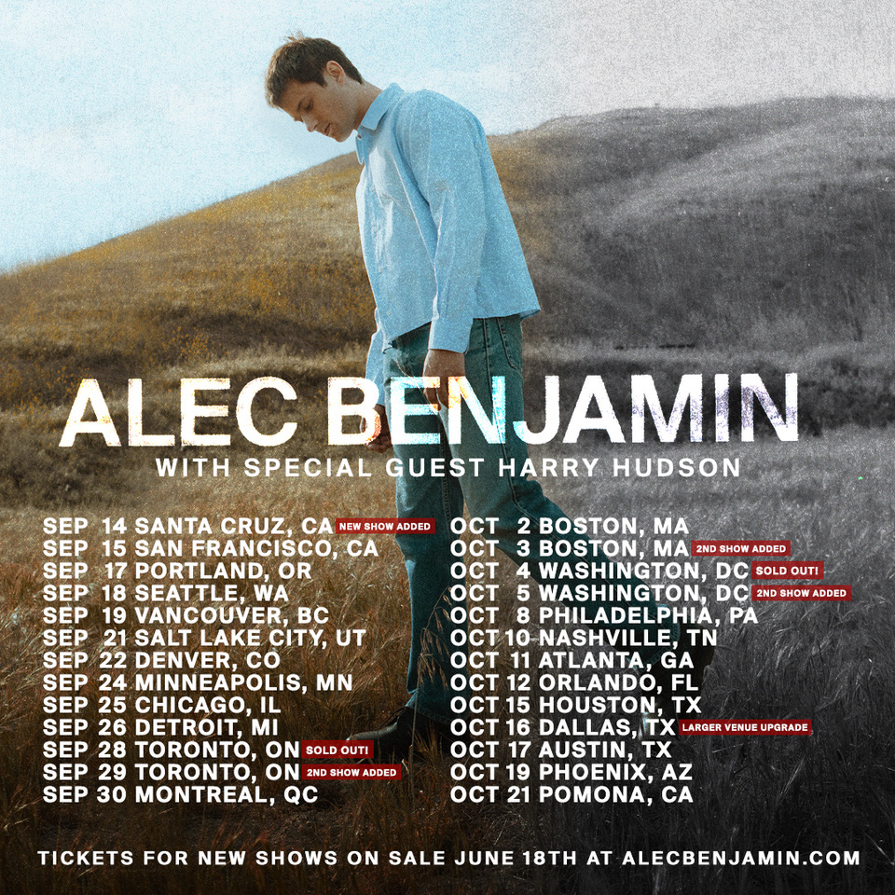

Multi-platinum singer-songwriter **Alec Benjamin** has announced additional dates on his upcoming North American Tour. The 23-city trek will now kick off in Santa Cruz, CA on September 14, and wrap on October 21 in Pomona, CA. Due to overwhelming demand, Alec has announced additional nights in Toronto, Boston, and Washington, DC, and upgraded his Dallas show to a larger venue. Tickets for the new dates will be available this Friday, June 18 at 10:00am local time [HERE](https://nam04.safelinks.protection.outlook.com/?url=https%3A%2F%2Fwww.alecbenjamin.com%2Ftour%2F&data=04%7C01%7CSydneyWorden%40elektra.com%7Cdc1fa53d778644bdac9a08d930e29010%7C8367939002ec4ba1ad3d69da3fdd637e%7C0%7C0%7C637594571971225436%7CUnknown%7CTWFpbGZsb3d8eyJWIjoiMC4wLjAwMDAiLCJQIjoiV2luMzIiLCJBTiI6Ik1haWwiLCJXVCI6Mn0%3D%7C1000&sdata=P%2FT5BN0XYUQNBffybv%2BREPsSFoT0rL0dsBelgJX6UEg%3D&reserved=0). Special guest Harry Hudson will provide support on the tour.

Alec Benjamin’s latest single “The Way You Felt” was released earlier this Spring and is available to stream and download now [HERE](https://nam04.safelinks.protection.outlook.com/?url=https%3A%2F%2Falecbenjamin.lnk.to%2FTWYF&data=04%7C01%7CSydneyWorden%40elektra.com%7Cdc1fa53d778644bdac9a08d930e29010%7C8367939002ec4ba1ad3d69da3fdd637e%7C0%7C0%7C637594571971235427%7CUnknown%7CTWFpbGZsb3d8eyJWIjoiMC4wLjAwMDAiLCJQIjoiV2luMzIiLCJBTiI6Ik1haWwiLCJXVCI6Mn0%3D%7C1000&sdata=mNtancbPdVi3iNs1IQI4xjjaja3WokPGQsvB%2BrcNByU%3D&reserved=0) via Elektra Records. Watch the track’s lyric video [HERE](https://nam04.safelinks.protection.outlook.com/?url=https%3A%2F%2Fyoutu.be%2FUt85dWwrTV8&data=04%7C01%7CSydneyWorden%40elektra.com%7Cdc1fa53d778644bdac9a08d930e29010%7C8367939002ec4ba1ad3d69da3fdd637e%7C0%7C0%7C637594571971235427%7CUnknown%7CTWFpbGZsb3d8eyJWIjoiMC4wLjAwMDAiLCJQIjoiV2luMzIiLCJBTiI6Ik1haWwiLCJXVCI6Mn0%3D%7C1000&sdata=BkSjqNwx9khhPjS7Oqeh5zhOvs4iqBTaOgswBam8nqQ%3D&reserved=0). Last month, Alec delivered the song’s network television performance on *The Late Late Show with James Corden*. Watch the clip [HERE](https://nam04.safelinks.protection.outlook.com/?url=https%3A%2F%2Fwww.youtube.com%2Fwatch%3Fv%3DFQyYmDzpBZY&data=04%7C01%7CSydneyWorden%40elektra.com%7Cdc1fa53d778644bdac9a08d930e29010%7C8367939002ec4ba1ad3d69da3fdd637e%7C0%7C0%7C637594571971245421%7CUnknown%7CTWFpbGZsb3d8eyJWIjoiMC4wLjAwMDAiLCJQIjoiV2luMzIiLCJBTiI6Ik1haWwiLCJXVCI6Mn0%3D%7C1000&sdata=ANuFmcl8XxeV4csWg0Rzx1k6D9BZ6CQ7U299FeEtM0M%3D&reserved=0). In honor of Mother’s Day, Corden and his mother Margaret also welcomed Alec and his mother Janet onto the show for a special interview. Watch it [HERE](https://nam04.safelinks.protection.outlook.com/?url=https%3A%2F%2Fwww.youtube.com%2Fwatch%3Fv%3DS0XLh1Kh89w&data=04%7C01%7CSydneyWorden%40elektra.com%7Cdc1fa53d778644bdac9a08d930e29010%7C8367939002ec4ba1ad3d69da3fdd637e%7C0%7C0%7C637594571971245421%7CUnknown%7CTWFpbGZsb3d8eyJWIjoiMC4wLjAwMDAiLCJQIjoiV2luMzIiLCJBTiI6Ik1haWwiLCJXVCI6Mn0%3D%7C1000&sdata=9ZB4pNu3tMcP0m5SGY2KdtqfW8UYF0BmRX18zS4wvFU%3D&reserved=0).

Last week Alec unveiled a Mandarin version of the track. “你的目光 (The Way You Felt)” is available to stream and download now [HERE](https://nam04.safelinks.protection.outlook.com/?url=https%3A%2F%2Falecbenjamin.lnk.to%2FTWYFmandarin&data=04%7C01%7CSydneyWorden%40elektra.com%7Cdc1fa53d778644bdac9a08d930e29010%7C8367939002ec4ba1ad3d69da3fdd637e%7C0%7C0%7C637594571971255418%7CUnknown%7CTWFpbGZsb3d8eyJWIjoiMC4wLjAwMDAiLCJQIjoiV2luMzIiLCJBTiI6Ik1haWwiLCJXVCI6Mn0%3D%7C1000&sdata=GAppF5p3zVYyvJw6mZALUTR2%2FAsXeEVIx%2BUBwOC8BTA%3D&reserved=0). The song marked Alec’s first official Mandarin release, and immediately shot to #1 on NetEase Music’s Western New Music Chart in China, surpassing new releases from artists including Lorde and Maroon 5. Competing with both domestic and international releases, the track also climbed to #2 on the platform’s Viral Chart and #8 on the New Music Chart. After resuming his study of the language during the COVID-19 pandemic, Alec collaborated with Chinese actress and singer Zhao Lusi on a Mandarin version of his hit single “Water Fountain”, earlier this year. Watch their duet on his YouTube channel [HERE](https://nam04.safelinks.protection.outlook.com/?url=https%3A%2F%2Fwww.youtube.com%2Fwatch%3Fv%3Du_yiFPJF58o&data=04%7C01%7CSydneyWorden%40elektra.com%7Cdc1fa53d778644bdac9a08d930e29010%7C8367939002ec4ba1ad3d69da3fdd637e%7C0%7C0%7C637594571971265415%7CUnknown%7CTWFpbGZsb3d8eyJWIjoiMC4wLjAwMDAiLCJQIjoiV2luMzIiLCJBTiI6Ik1haWwiLCJXVCI6Mn0%3D%7C1000&sdata=EaR15QUpfYXnDxKhecAoizzg7N%2F9rlNnAGBishYfFZo%3D&reserved=0).

“The Way You Felt” follows Alec’s critically acclaimed 2020 debut studio album, *These Two Windows*. Generating nearly half-a-billion streams in under a year, it boasts the hit singles “Jesus In LA,” “Oh My God,” and “Mind Is A Prison.” Attracting widespread praise, *People* raved, *“The album is a major milestone*,*”* and *Stereogum* christened him *“A fascinating voice in modern pop*.*”* In addition to plugs from *The New York Times, American Songwriter* and more, *Billboard* noted, *“The rising pop singer-songwriter succeeds in making the matter distinctive by how much his lyrics read like a heart-to-heart conversation*.*”*

Stay tuned for more news from Alec Benjamin very soon.

**Alec Benjamin North American Tour Dates**

September 14, 2021 - Santa Cruz, CA - The Catalyst*

September 15, 2021 - San Francisco, CA - The Warfield

September 17, 2021 - Portland, OR - McMenamin’s Crystal Ballroom

September 18, 2021 - Seattle, WA - Showbox SoDo

September 19, 2021 - Vancouver, BC - Vogue Theatre

September 21, 2021 - Salt Lake City, UT - The Complex

September 22, 2021 - Denver, CO - Mission Ballroom

September 24, 2021 - Minneapolis, MN - Fillmore Minneapolis

September 25, 2021 - Chicago, IL - Riviera Theatre

September 26, 2021 - Royal Oak, MI - Royal Oak Music Theatre

September 28, 2021 - Toronto, ON - The Danforth Music Hall - **SOLD OUT**

September 29, 2021 - Toronto, ON - The Danforth Music Hall*

September 30, 2021 - Montreal, QC - MTELUS

October 02, 2021 - Boston, MA - House Of Blues - Boston

October 03, 2021 - Boston, MA - House of Blues Boston*

October 04, 2021 - Washington, DC - 9:30 Club - **SOLD OUT**

October 05, 2021 - Washington, DC - 9:30 Club*

October 08, 2021 - Philadelphia, PA - Franklin Music Hall

October 10, 2021 - Nashville, TN - Marathon Music Works

October 11, 2021 - Atlanta, GA - Tabernacle

October 12, 2021 - Orlando, FL - The Beacham

October 15, 2021 - Houston, TX - House Of Blues - Houston#

October 16, 2021 - Dallas, TX - The Bomb Factory^#

October 17, 2021 - Austin, TX - Emo’s Austin

October 19, 2021 - Phoenix, AZ - The Van Buren

October 21, 2021 - Pomona, CA - The Glass House

*On sale this Friday at 10:00am local time

^Upgraded from Canton Hall

#No Harry Hudson



*Photo Credit: Matty Vogel*

***

As popular music gets more and more *“genre-less*,*”* Alec Benjamin has only gotten more and more era-less. You can’t pin his candid storytelling, warm melodies, sticky hooks, and natural production to any age. That’s why he’s quietly become his generation’s own troubadour. Thus far, he has amassed nearly four billion streams, 820 million YouTube views, and multiple gold and platinum singles. He has sold out shows on three continents and counts Billie Eilish and John Mayer among his most vocal and ardent fans. Not to mention, he’s collaborated with everyone from Alessia Cara to Chinese superstar Zhao Lusi. His 2018 mixtape, *Narrated For You*, picked up a gold certification, while the 2020 debut album, *These Two Windows*, arrived to widespread critical acclaim from *Billboard*, *People*, *Stereogum*, and more. After a Global Pandemic, a year of soul-searching, and countless hours writing, he returns with his new single “The Way You Felt.”

**CONNECT:**

[Facebook](https://nam04.safelinks.protection.outlook.com/?url=https%3A%2F%2Fwww.facebook.com%2FAlecBenjaminMusic&data=04%7C01%7CSydneyWorden%40elektra.com%7Cdc1fa53d778644bdac9a08d930e29010%7C8367939002ec4ba1ad3d69da3fdd637e%7C0%7C0%7C637594571971265415%7CUnknown%7CTWFpbGZsb3d8eyJWIjoiMC4wLjAwMDAiLCJQIjoiV2luMzIiLCJBTiI6Ik1haWwiLCJXVCI6Mn0%3D%7C1000&sdata=V5e5y1DoHV%2FySj4nkauXAMyyWnzltixjcM9Og%2B%2ByaYc%3D&reserved=0) | [Twitter](https://nam04.safelinks.protection.outlook.com/?url=https%3A%2F%2Ftwitter.com%2FAlecBenjamin%3Fref_src%3Dtwsrc%25255Egoogle%25257Ctwcamp%25255Eserp%25257Ctwgr%25255Eauthor&data=04%7C01%7CSydneyWorden%40elektra.com%7Cdc1fa53d778644bdac9a08d930e29010%7C8367939002ec4ba1ad3d69da3fdd637e%7C0%7C0%7C637594571971275404%7CUnknown%7CTWFpbGZsb3d8eyJWIjoiMC4wLjAwMDAiLCJQIjoiV2luMzIiLCJBTiI6Ik1haWwiLCJXVCI6Mn0%3D%7C1000&sdata=RKYIZq4fzgVSqSrSyvTQYuXDXekMY7z%2B4zbLRjAjHT8%3D&reserved=0) | [Instagram](https://nam04.safelinks.protection.outlook.com/?url=https%3A%2F%2Fwww.instagram.com%2Falecbenjamin%2F%3Fhl%3Den&data=04%7C01%7CSydneyWorden%40elektra.com%7Cdc1fa53d778644bdac9a08d930e29010%7C8367939002ec4ba1ad3d69da3fdd637e%7C0%7C0%7C637594571971275404%7CUnknown%7CTWFpbGZsb3d8eyJWIjoiMC4wLjAwMDAiLCJQIjoiV2luMzIiLCJBTiI6Ik1haWwiLCJXVCI6Mn0%3D%7C1000&sdata=HxJ2AIkLvUkOsyutqif3%2Fg%2Bp2Pm%2BEoBafsx%2FNw2gYm8%3D&reserved=0) | [YouTube](https://nam04.safelinks.protection.outlook.com/?url=https%3A%2F%2Fwww.youtube.com%2Fchannel%2FUCtWBCzqucZXq0M8jsqunM0g&data=04%7C01%7CSydneyWorden%40elektra.com%7Cdc1fa53d778644bdac9a08d930e29010%7C8367939002ec4ba1ad3d69da3fdd637e%7C0%7C0%7C637594571971285398%7CUnknown%7CTWFpbGZsb3d8eyJWIjoiMC4wLjAwMDAiLCJQIjoiV2luMzIiLCJBTiI6Ik1haWwiLCJXVCI6Mn0%3D%7C1000&sdata=2QDpdknMrS76vZum07Fx2cZwMmWOVyZi2SsiPptUCho%3D&reserved=0)

**CONTACT:**

Glenn Fukushima | [GlennFukushima@elektra.com](mailto:GlennFukushima@elektra.com)

 Collin Citron | [CollinCitron@elektra.com](mailto:CollinCitron@elektra.com)