ANNA OF THE NORTH & GUS DAPPERTON INVITE YOU TO THE WORLD OF “METEORITE”
VIA ELEKTRA RECORDS
LISTEN HERE
WATCH HERE
+FIRST OF NEW MUSIC+
+performing at Firefly Festival September 2022+
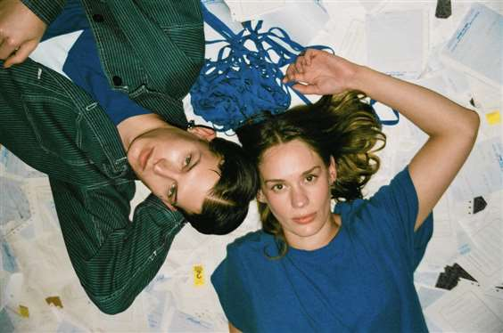
May 11, 2022 – Today, Anna of the North releases the first of new music with the Gus Dapperton collaboration “Meteorite.” The track intertwines Anna and Gus’ heartfelt vocals with an infectious melody complete with a cinematic visual. Watch here.
Featuring lo-fi hues of blue, the music video introduces viewers to Anna and Gus’s laundromat love story. The two meet on a seemingly mundane day and watch as their worlds and energy combine. “Meteorite” encapsulates how the smallest encounter can impact everyday life. Between the acoustic guitar stylings and crooning vocals, “Meteorite” is an enthralling medley of long-distance love.
Speaking of the track Anna states “Meteorite is a song that was originally written by Gus. He asked if I wanted to put a verse on it and collaborate which I, of course, wanted to do - I’m a big fan of him. I love the song and I’m so happy with how it came out. Our voices work really well together. It’s a song about distance and how energy always connects us.”
With 500M+ streams under her belt, co-signs from Tyler The Creator, Dua Lipa, Alina Baraz, Rejjie Snow, Steve Lazy and more, Anna of the North is the pop star who has been hiding in plain sight.
Anna won a Norwegian Grammy Award (Spellemannprisen) for her music video "Dream Girl". Additionally, she had a track synced to a Global iPad Pro Commercial (+ 2 Netflix shows), 'opened' for Katy Perry, & performed at the first ever Zoomtopia. Her track "Dream Girl" was featured in the 3rd film in the trilogy 'To All The Boys...Always & Forever' - she's the only artist featured in all three films. All of her syncs became viral moments but the iPad Pro sync saw overnight success, and in less than a week Anna was charting on iTunes in over 30+ Countries, doubled her Daily Spotify Streams and saw an overall streaming increase of 187%.
Recently, Anna has been on the reality TV show Hver Gang Vi Mötes. The show has broken more artists and resurrected more artist careers than any other media in any of the countries where it currently airs.
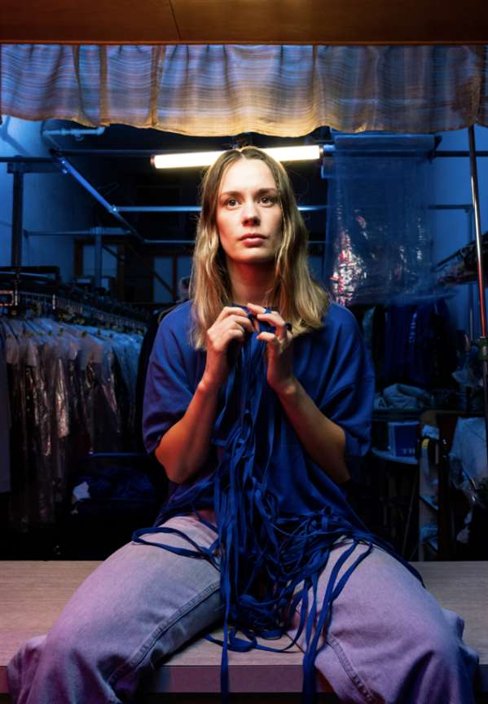
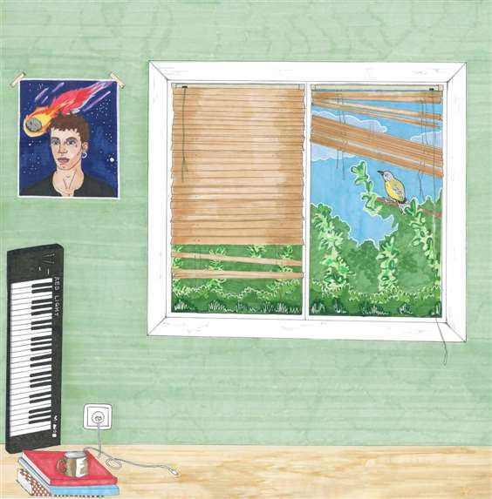
About Anna of the North
Anna of the North strikes an emotional chord regardless of continent, collaborator, or genre and her music has taken on an unexpected life of its own as it finds success in syncs. Few modern artists could appear as at home working with Tyler, the Creator (Anna lent her vocals to two tracks on ‘Flower Boy’ alongside Steve Lacy, Frank Ocean, and Rex Orange County) and Rejjie Snow as they are duetting with HONNE or playing with Anderson Paak. All of which has led Anna to where she finds herself in now; a pop star and a fearless young woman who is set to make 2022 her year.

