A DAY TO REMEMBER
SHARE NEW SINGLE “EVERYTHING WE NEED”

LISTEN HERE

ACOUSTIC LIVE ALBUM A DAY TO REMEMBER - LIVE AT THE AUDIO COMPOUND
AVAILABLE NOW ON ALL DSPS

NEW STUDIO ALBUM YOU’RE WELCOME ARRIVES ON MARCH 5TH

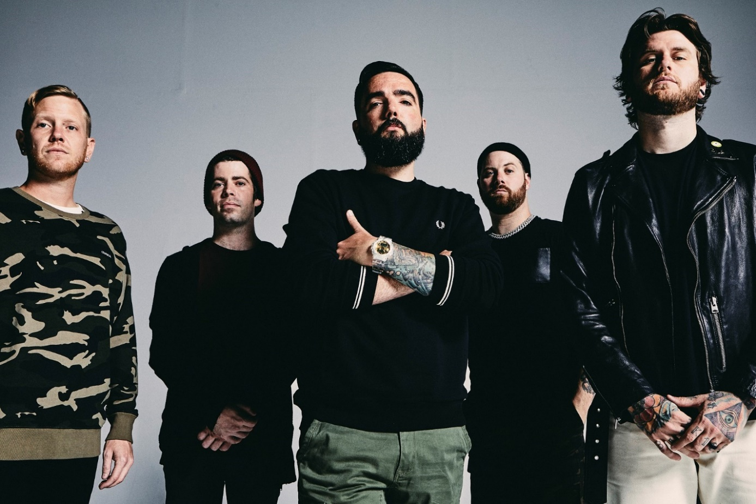
PHOTO CREDIT: JIMMY FONTAINE

JANUARY 27, 2021 - A Day To Remember have shared their brand-new single “Everything We Need” which is available now on all streaming platforms. It is the latest song to be revealed from their widely-anticipated forthcoming album, You’re Welcome—set for release March 5th, 2021.
Co-written with multi-platinum superstar Jon Bellion, “Everything We Need” bookends the album as an understated, yet uplifting exhale of emotion. Illuminating another aspect of their sound, it also continues a tradition of standout stripped-down tunes over the years.

A Day To Remember’s Jeremy McKinnon elaborated on the song’s genesis explaining, “This was one of the song ideas I started with Jon Bellion and ended up finishing later on with the help of Nick Long. A song about going on a drive to clear your head and having a pinch me moment. Realizing you have everything in life you need right now.”

This past Monday, A Day To Remember debuted “Everything We Need” during their first-ever acoustic livestream event, “A Day To Remember: Live at The Audio Compound.” After premiering the stream on their official YouTube channel, the band surprised audiences everywhere by releasing the livestream as an acoustic live album, Live At The Audio Compound, on all DSPs. During the show, they performed a career-spanning nine-song set including recent singles [album art / full tracklisting below].

A Day To Remember heralded You’re Welcome with the new single “Brick Wall,” which is available on all streaming platforms. Inciting critical applause, Revolver declared, “[Brick Wall] showcases the group's signature mix of post-hardcore heaviness and pop-rock hooks,” while Consequence of Sound praised the track’s, “melodic beginning and a crushing ending.” Forbes put it simply, “It seems A Day To Remember are only just getting started.” Recently, they also dropped an acoustic video of “Degenerates,” which was shot in Fall 2019 during their sold-out run of homecoming headline shows.” “Degenerates (Live Acoustic)” is streaming HERE.

Pre-orders for You’re Welcome are live now featuring exclusive merch bundles and multiple vinyl variants of the LP. All pre-orders for You’re Welcome will unlock instant grat downloads of “Everything We Need” an “Brick Wall” as well as the previously released singles “Degenerates,” “Resentment,” and “Mindreader.”

Largely produced by Colin “DOC” Brittain and the band’s own Jeremy McKinnon, the 14-tracks on You’re Welcome represent another major step forward for the acclaimed quintet. Highlights include “Bloodsucker” which ravages with an infectious intensity, while “F.Y.M.” spouts punk energy through an unforgettable chorus. “Viva La Mexico” builds to a stadium-sized chant backed by walls of guitars, whereas “Everything We Need” closes out the album with a plaintive melody and acoustic eloquence, once more showcasing A Day To Remember’s multifaceted songwriting. [album art / tracklisting below].

A Day To Remember preceded You’re Welcome with the release of “Mindreader” last year. Since then, the track has amassed over 20 million global streams while its animated music video has generated over two million views. “Mindreader” followed early standalone singles “Degenerates” and “Resentment” which have collectively amassed over 100 million global streams. Billboard praised “Degenerates” as “an anthemic hybrid of post-hardcore and pop,” while Kerrang! hailed, “‘Resentment’ offers a taste of the musical direction the band are heading, and will certainly tide us over until more news arrives.”

A DAY TO REMEMBER
LIVE AT THE AUDIO COMPOUND

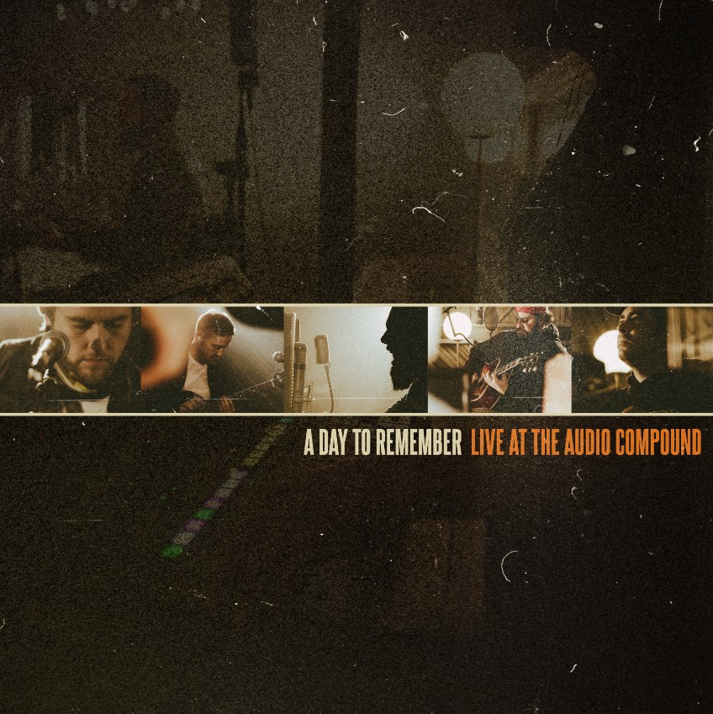
1. Mindreader (Live at TAC)
2. I Surrender (Live at TAC)
3. Resentment (Live at TAC)
4. I’m Already Gone (Live at TAC)
5. If It Means a Lot To You (Live at TAC)
6. Rescue Me (Live at TAC)
7. Degenerates (Live at TAC)
8. Take Cover (Live at TAC)
9. Everything We Need (Live at TAC)

A DAY TO REMEMBER
YOU’RE WELCOME
RELEASE DATE: MARCH 5TH

1. Brick Wall
2. Mindreader
3. Bloodsucker
4. Last Chance to Dance (Bad Friend)
5. F.Y.M.
6. High Diving
7. Resentment
8. Looks Like Hell
9. Viva La Mexico
10. Only Money
11. Degenerates
12. Permanent
13. Re-Entry
14. Everything We Need

ABOUT A DAY TO REMEMBER:
Since their formation in 2003, A Day To Remember quietly emerged as arguably the biggest underground band in the world. The Florida group affirmed this status by achieving one platinum album, one gold album, one platinum single, and four gold singles. Not to mention, each full-length record ascended to #1 on the Billboard Rock, Indie, and/or Alternative Charts with 2016’s Bad Vibrations bowing at #2 on the Billboard Top 200. They’ve put up unprecedented numbers for a rock act in the 21st century, generating 850 million Spotify streams, 500 million YouTube views, and sales of three million-plus units. They’ve also packed arenas on continental tours and attracted a worldwide audience consisting of millions. Additionally, A Day To Remember successfully launched their own Self Help Festival in 2014, which continues going strong. Plus, everyone from Marshmello to Pierce The Veil has sought them out for collaborations. All of which explains why Rolling Stone called them “An Artist You Need To Know.”

A Day To Remember is: Jeremy McKinnon (vocals), Alex Shelnutt (drums), Kevin Skaff (guitar, vocals), Neil Westfall (guitar, vocals), and Joshua Woodard (bass).

Connect with A Day To Remember:
WEBSITE
FACEBOOK
TWITTER
INSTAGRAM
YOUTUBE
SPOTIFY
APPLE MUSIC

Contact:
Ross Anderson / RossAnderson@elektra.com

