FOR IMMEDIATE RELEASE

THE BAND CAMINO DROPS NEW SINGLE AND VIDEO TODAY FOR
“1 LAST CIGARETTE”
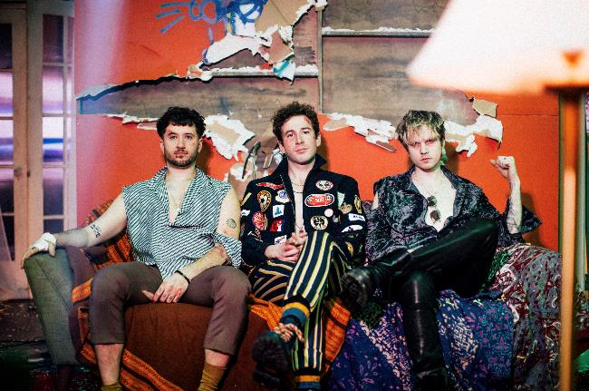
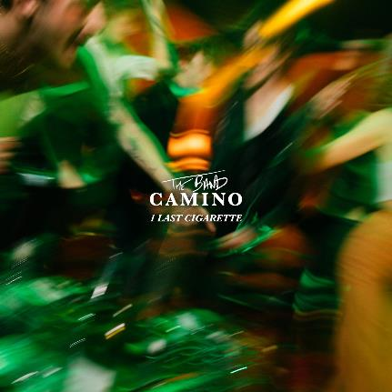
Los Angeles, CA (February 26, 2021)--Pop/rock group The Band CAMINO returns with their newest track released today titled “1 Last Cigarette” on dblblk/Elektra Records. The band’s new song follows their previous singles "Roses," and their Chelsea Cutler collaboration “Crying Over You,” which have amassed more than 24 million global streams to date. The tracks preview The Band CAMINO's highly anticipated full-length album, which is expected later this year. Stream “1 Last Cigarette” here and watch the music video here.

Leading with the band’s signature vibrant sound, the new single encapsulates the euphoria of a great night and the residual after-buzz that permeates when it ends. Spencer Stewart says, “I could tell you this song is about how using alcohol as a coping mechanism perpetuates already unhealthy habits, or use it as a social commentary on youth party culture, but really it's just about getting drunk and losing my keys."

Dubbed "Rock's next big thing" by Billboard, The Band CAMINO writes lovelorn songs about perseverance and personal growth. The group has released three EP's: 2019's tryhard, 2017's Heaven and 2016's My Thoughts On You, featuring an array of anthemic singles that have collectively amassed more than 300 million streams around the globe. tryhard, their Elektra Records debut EP, overflows with massive hooks, highlighted by the sharp and reflective singles: "Daphne Blue," "See Through," and "Honest." "Daphne Blue" which made waves on AltNation spending multiple weeks at #1 on the Alt18 countdown, while the band received additional media coverage from Billboard, Ones To Watch, LADYGUNN, Paste, Consequence of Sound, American Songwriter, Elite Daily, LA Weekly, and more. 2019 also saw The Band CAMINO embark on a completely sold-out U.S. headline tour, along with festival appearances at Forecastle, Lollapalooza, and Austin City Limits, where they were named a "breakout act" by Grammy.com. More recently, The Band CAMINO was handpicked to be the main support on Dan + Shay's arena tour, and were tapped by 5 Seconds of Summer to support them stateside.
Hailing from Memphis, and now based in Nashville, Jeffrey Jordan (vocals, guitar), Spencer Stewart (vocals, guitar) and Garrison Burgess (drums), friends since their high school days, formed The Band CAMINO in 2015, while attending the University of Memphis. The band independently released singles such as "2 / 14," and the piano ballad "The Black and White," and became a major streaming success in the latter half of the 2010s. They self-released their debut EP, My Thoughts on You and a second EP, Heaven, in 2017. The band notched big streaming numbers with 2018 singles: "Less Than I Do" and "Know Me." After signing a major-label deal with Elektra Records, the band issued their full-length debut, tryhard, in 2019.

The band is signed to dblblk/Elektra Records, a partnership between Elektra Music Group and The Band CAMINO's manager Jameson Roper.

Stream 1 Last Cigarette here.

Follow The Band CAMINO: Instagram | Twitter | YouTube

####

Contact:

Jeff Raymond
jeff.raymond@rogersandcowanpmk.com

Lori Lousararian-Hakola
lori.lousararian@rogersandcowanpmk.com

Jennifer Kelleher
jennifer.kelleher@rogersandcowanpmk.com

Amy McBrayer
amy.mcbrayer@rogersandcowanpmk.com

